|  |
| --- |
| Labour Management System |



**Author:**

1. Xuan Dong Thi Thanh - Student1272834 (Leader)

2. Lan Nguyen Binh Phuong - Student1273079

3. Dac Pham Danh – Student1269153

**Instructor:**

Mr. Nguyen Truong Ngoc Khac

**Date:** 7th October 2021

**Semester:** 2

Centre Name: **Aprotrain Aptech**

TABLE OF Contents

ABSTRACT 1

CHAPTER 1: OVERVIEW 2

1. INTRODUCTION 2

2. SITEMAP 2

3. OBJECTIVE 5

4. SOME MAIN INTERFACE 6

CHAPTER 2: E-PROJECT DESIGN 7

1. DATA-FLOW DIAGRAM 7

1.1. Defination 7

1.2. Elements of data-flow diagrams 7

2. DFD ANALYSIS: DESIGN MAIN FUNCTIONS OF SYSTEM 8

3. DATABASE STRUCTURE 20

CHAPTER 3: INTERFACE SNAPSHOT 21

1. MAIN 21

2. ATTANDANCE RECORD 22

3. LOGIN 22

4. CHOOSE TYPE 23

5. ADMIN OFFICER 24

6. HUMAN RESOURCES 25

7. EMPLOYEE 26

CHAPTER 4: EMPLOYEE GUIDE 27

1. MAIN 27

1.1. Description 27

1.2. Design and operation 27

2. ATTENDANCE RECORD 28

2.1. Description 28

2.2. Design and operation 28

3. LOGIN 34

3.1. Description 34

3.2. Design and operation 34

4. MY PROFILE 35

4.1. Description 35

4.2. Design and operation 35

5. CALENDAR 36

5.1. Description 36

5.2. Design and operation 36

6. CREATE REQUEST 37

6.1. Description 37

6.2. Design and operation 37

6.2.1. Request leave 37

6.2.2. Request change shift (only employee account) 42

7. Notification 43

7.1. Description 43

7.2. Design and operation 44

8. CHANGE PASSWORD 46

8.1. Description 46

8.2. Design and operation 46

9. LOG OUT 47

9.1. Description 47

9.2. Design and operation 47

CHƯƠNG 5: ADMIN GUIDE 50

1. MAIN 50

2. ATTENDANCE RECORD 50

3. LOGIN 50

4. HOMEPAGE 50

4.1. Description 50

4.2. Design and operation 50

5. ARRANGE SHIFT 57

5.1. Description 57

5.2. Design and operation 57

6. REQUEST 58

6.1. Description 58

6.2. Design and operation 59

6.2.1. Request change shift 59

6.2.2. Request leave 60

7. REPORT 63

7.1. Description 63

7.2. Design and operation 64

8. LOG OUT AND BACK 67

8.1. Description 67

8.2. Design and operation 67

CHAPTER 6: HR GUIDE 69

1. MAIN 69

2. ATTENDANCE RECORD 69

3. LOGIN 69

4. EMPLOYEE 69

4.1. Description 69

4.2. Design and operation 69

5. EMPLOYEE DETAIL INFORMATION 71

5.1. Description 71

5.2. Design and operation 71

6. ADD NEW EMPLOYEE 73

6.1. Description 73

6.2. Design and operation 73

7. REQUEST 78

7.1. Description 78

7.2. Design and operation 78

8. PAYROLL 79

8.1. Description 79

8.2. Design and operation 79

9. REPORT 82

9.1. Description 82

9.2. Design and operation 82

10. LOG OUT AND BACK 84

10.1. Description 84

10.2. Design and operation 84

CHAPTER 7: DEVELOPER GUIDE 86

1. INSTALL SQL SERVER 86

2. INSTALL JOB IN SQL SERVER. 87

3. INSTALL IN ECLIPSE-WORKSPACE. 94

4. RUN APPLICATION 94

|  |  |  |
| --- | --- | --- |
| **STUDENT** | **TASK ASSIGNMENT** | **DETAIL** |
| Xuan Dong Thi Thanh - Student1272834 (Leader) | Build Attendance Record and Admin | * Create DataBase * Build function timekeeping * Build Auto Arrange shift * Handle request leave and request shift. * Create Attendance Record report |
| Lan Nguyen Binh Phuong - Student1273079 | Build HR | * Mange employee information * Insert, delete, update employee info * Update leave * Calculation salary * Create salary report |
| Dac Pham Danh – Student1269153 | Build Client | * Show employee information * Review working calendar * Create leave request * Create change shift request * Change password |

**Task assignment:**

# colored rectanglecolored rectangleABSTRACT

In this world of growing technologies, everything has been computerized. With a large number of work opportunities, the human workforce has increased. Thus there is a need for a system that can handle the data of such a large number of employees in an organization. This project simplifies the task of maintaining records because of its user-friendly nature.

Today’s technology gives organizations the ability to stay connected with employees by providing streamlined communication. Think about those tedious tasks, from scheduling to recording and managing time-off requests. There are portals and platforms that digitize much of the information organizations need to process. These technologies also provide the opportunity to gain valuable insights by collecting data that are based on real information. This is useful for recruitment and hiring, absence management, employee discipline, shift planning, and much more.

The “Labour Management System” has been developed to override the problems prevailing in the practicing manual system. This software is supported to eliminate and in some cases reduce the hardships faced by this existing system. Moreover, this system is designed for the particular needs of the company to carry out operations in a smooth and effective manner.

The application is reduced as much as possible to avoid errors while entering the data. It also provides an error message while entering invalid data. No formal knowledge is needed for the user to use this system. Thus by this all, it proves it is user-friendly.

We have taken effort in this project. However, it would not have been possible without the kind supports and help of our instructor Mr.Nguyen Truong Ngoc Khac. We would like to extend our sincere thanks to Mr.Nguyen Truong Ngoc Khac. We would like to express our special gratitude Aptech Aprotrain for their guidance and constant supervision as well as for providing nessessary information regarding the project and also for their support in completing the project.



# CHAPTER 1: OVERVIEW

## 1. INTRODUCTION

This “Labour Management System” Project application stores all the employee’s information in a database. It is an application developed in Java GUI technology and database used is SQL Server Management. It contains employee information like employee id, fullname, department, relatives information and so on. This application supports timekeeping and monthly salary calculation for employees. Besides, it also assists in the management of employee leave and shifts.

It is an easy to use application and has a user-friendly interface. It is totally built at the administrative end which means that only the admin has access rights to change or modify any records. So this makes it safe and reliable application to use. The main aim of developing this application was to reduce the errors that occur in the manual system. One can search the details easily by just entering employee id, fullname. All the details are stored in an SQL Server database. It is easy to update any employee details. All the employee records include attendance and payroll are integrated and so this makes it user-friendly and easy to use application. Labour Management System Project in Java is Java project developed using java GUI or java swings and this comes under java projects with source code.

The application is to be developed for the Eclipse-workspace 2021 and Microsoft SQL Server Management Studio 18 2019.

## 2. SITEMAP

This application includes three types of user: administration, human resources, and employee.

* Administration function:

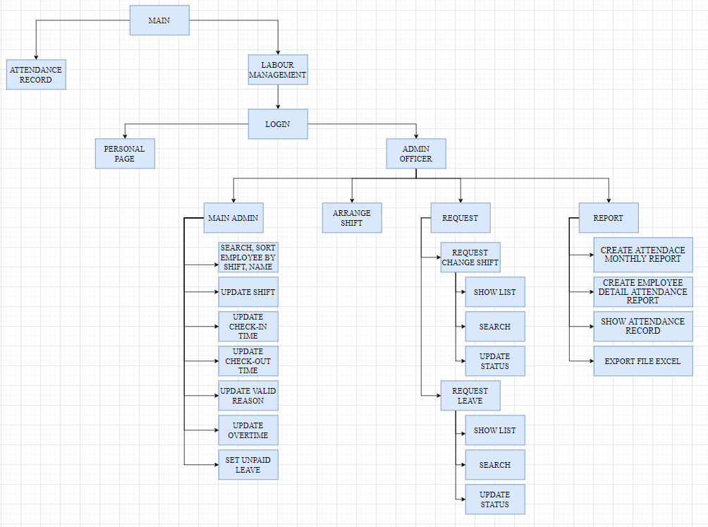

Figure 1.1. Administration

* Human resources function:

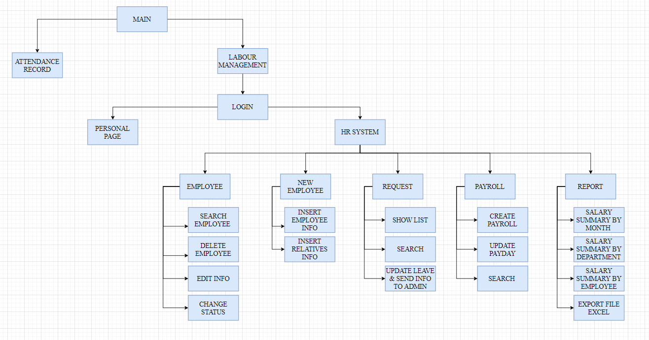

Figure 1.2. Human Resources

* Employee function:

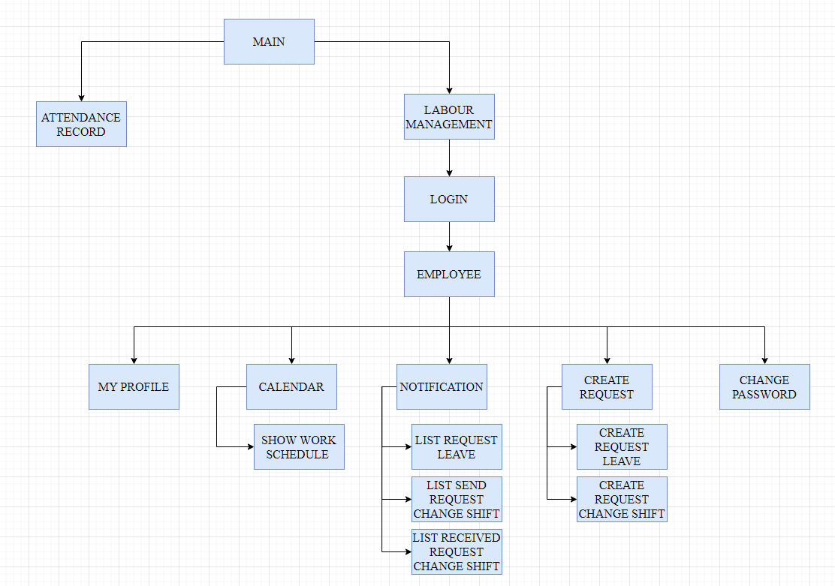

Figure 1.3. Employee

## 3. OBJECTIVE

The objective of the employee management system is to develop a simple and reliable system to achieve the goal of making manage profile, attendance, and salary calculation of employees easy and genuine. We aim to develop a system that prevents cheating by employees and make sure they get each penny of their hard work. This system is developed with the main objective to solve the problem of small-scale factories and businesses that are still using pen and paper to maintain staff records. These industries even face many clashes with employees as most of the staff working here is from the labor class and they really do hard work to earn, so our system will put an effort to reduce these clashes and will make sure that these workers get each penny of their work. This system will save a lot of time for the employer and reduce the tension of handling pay for employees. So, they can focus on other things and developing their businesses.

## 4. SOME MAIN INTERFACE

* **Main:** Display the application's logo along with 2 access options: time attendance or access to the management system.
* **Attandance:** Allows employees to search for information by entering phone numbers and making time attendance.
* **Login:** Employees log into the system with the provided username and password to access the system.
* **Choose type:** Interface for admin and HR accounts, showing 2 options: access client page (personal page) or management system.
* **Client:** Interface for employee accounts or admin and hr accounts when accessing personal pages.
* **Admin:** Admin interface to manage shift and timekeeping information.
* **HR:** Interface for HR account to manage employee's personal and salary information.



# CHAPTER 2: E-PROJECT DESIGN

## 1. DATA-FLOW DIAGRAM

### 1.1. Defination

The Data Flow Diagram (DFD) is a structured analysis and design method. It is a visual tool to depict logic models and expresses data transformation in a system. DFD includes a mechanism to model the data flow. It supports decomposition to illustrate details of the data flows and functions. DFD includes following characteristics:

1. supporting the analysis and requirement stage of system design;
2. a diagramming technique with annotation;
3. describing a network of activities/processes of the target system;
4. allowing for behaviors of parallel and asynchronous ;
5. stepwise refinement through hierarchical decomposition of processes.

### 1.2. Elements of data-flow diagrams

Four basic elements are used to construct data-flow diagrams:

* Processes
* Data-flows
* Data stores
* External entities

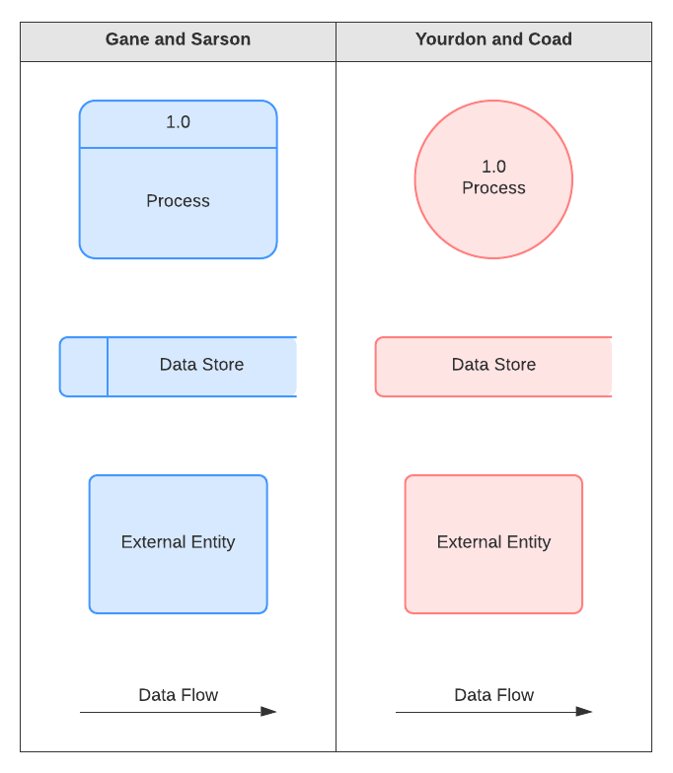

Figure 2.1. Component of DFD

## 2. DFD ANALYSIS: DESIGN MAIN FUNCTIONS OF SYSTEM

* Login

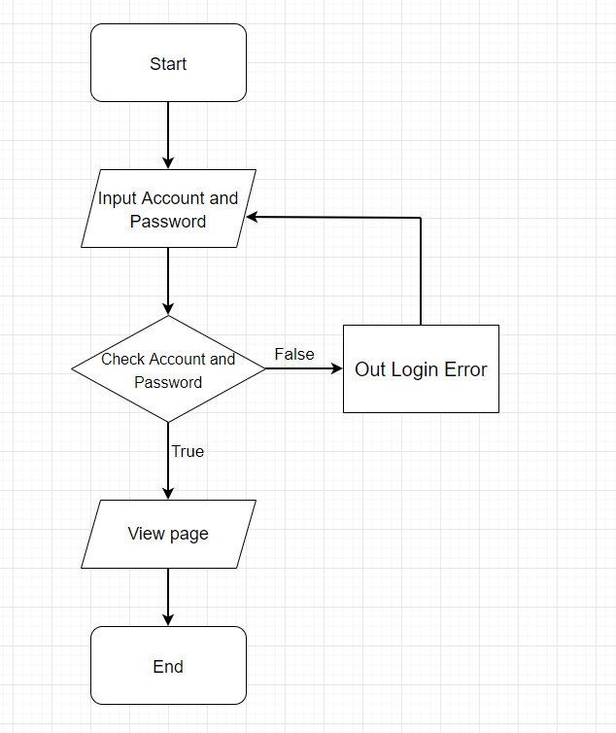

* Search phone – Timekeeping

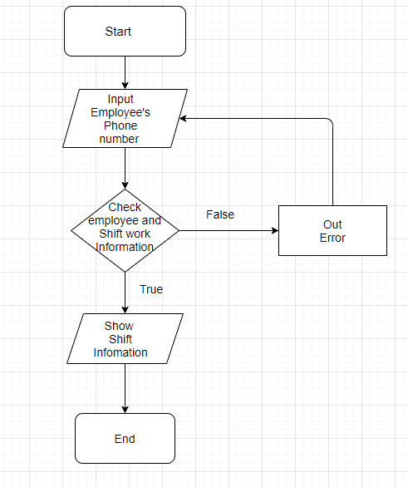

* Attendance record

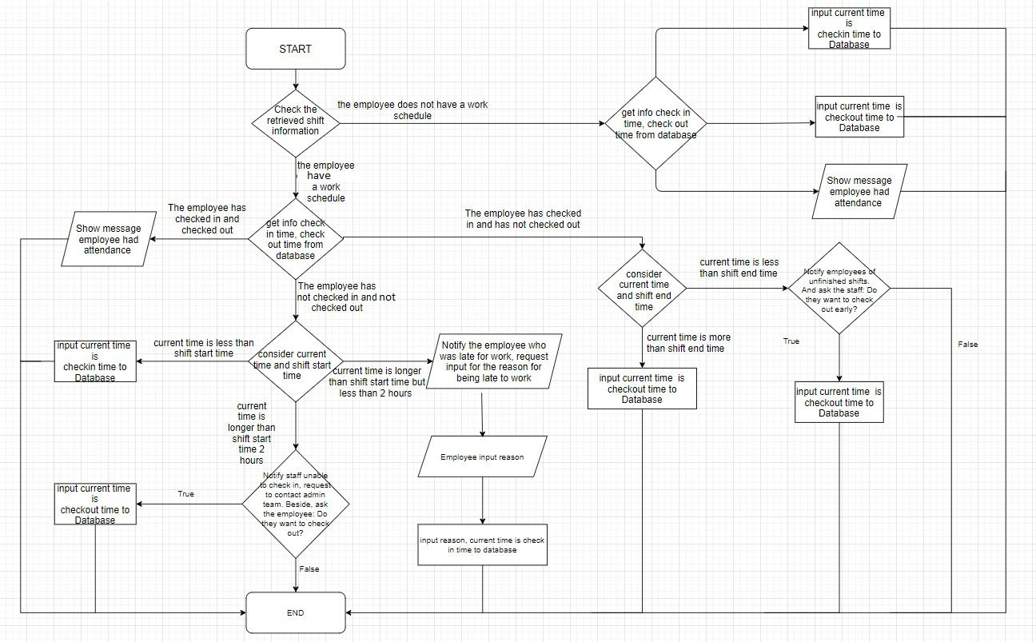

* Update check-in and check-out time (admin management).

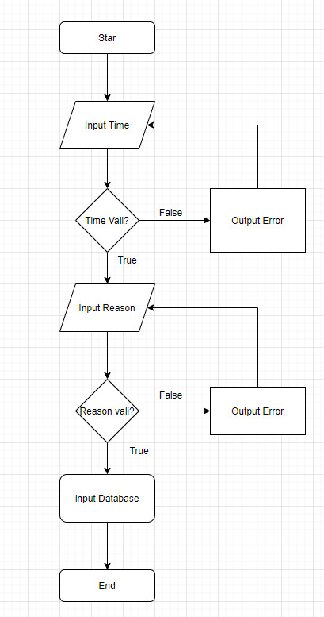

* Update shift

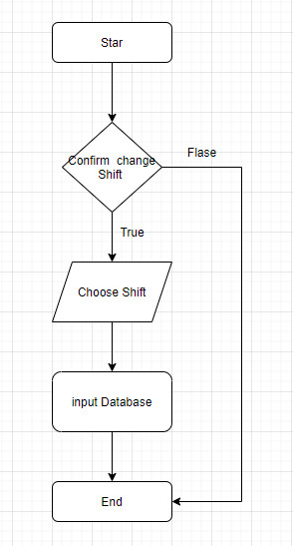

* Update valid reason

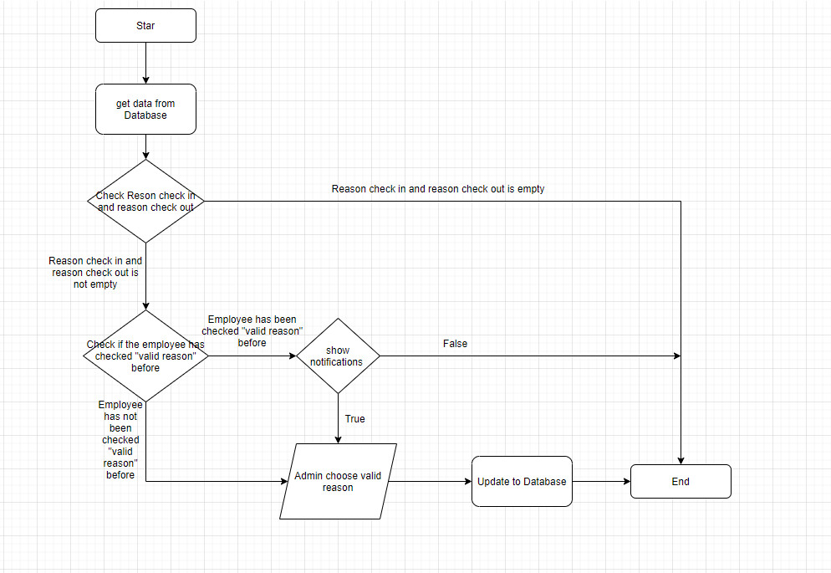

* Set overtime

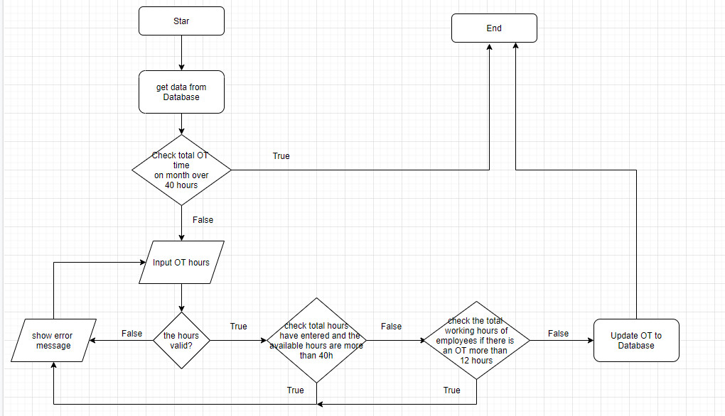

* Set Unpaid leave if an employee suddenly off without permission

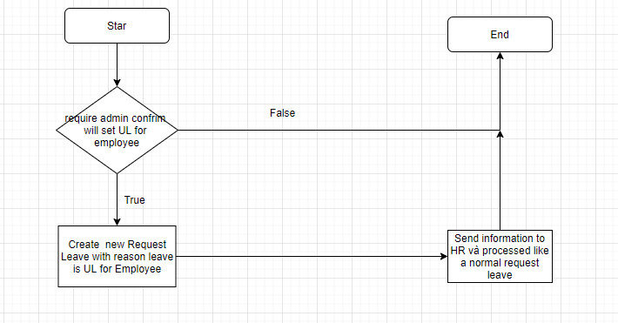

* Arrange shift

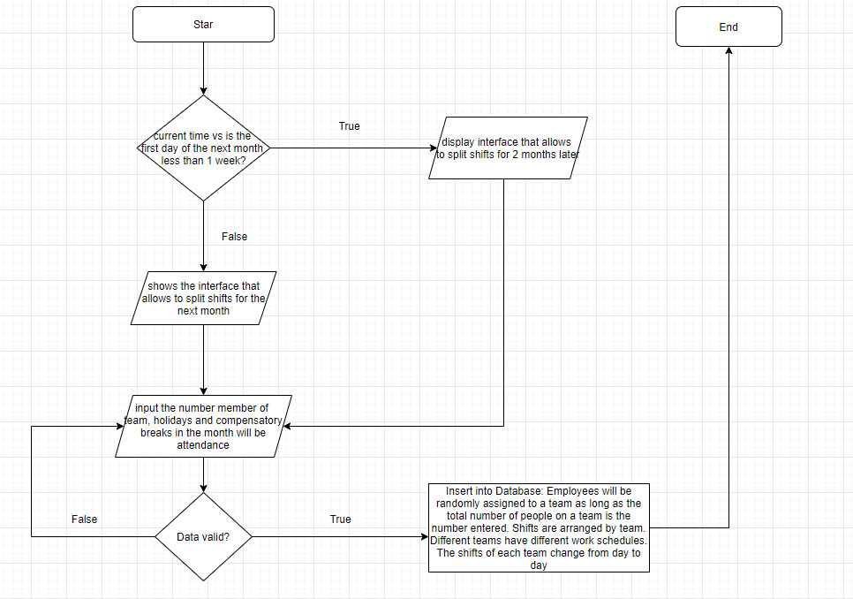

* Change password

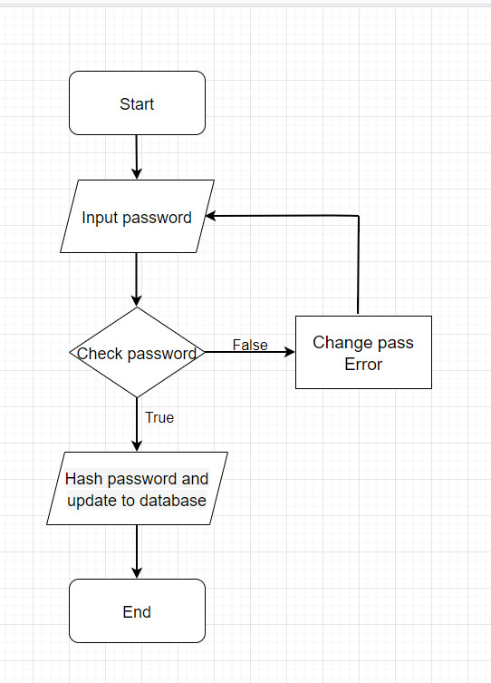

* Search information:

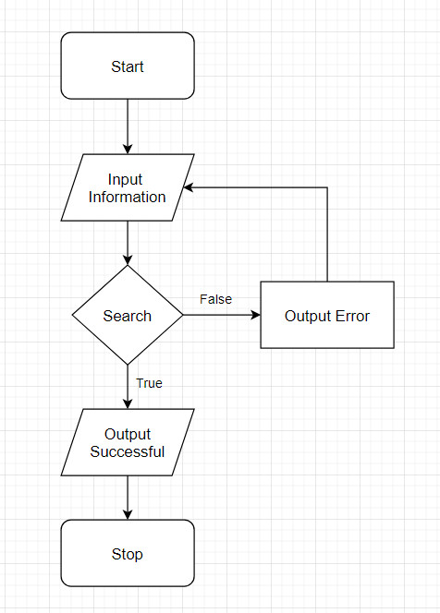

* Sort information

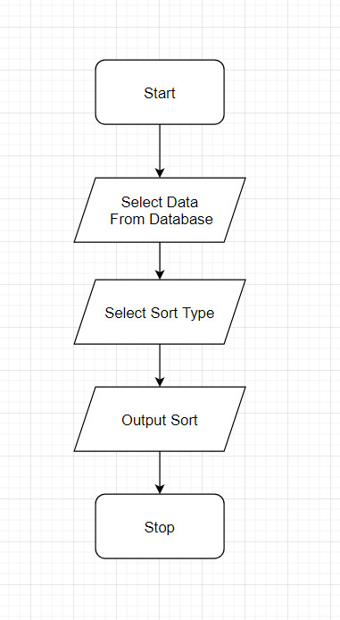

* Create request change shift

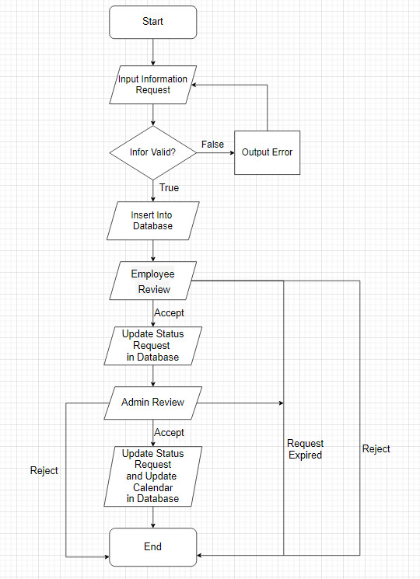

* Create request leave

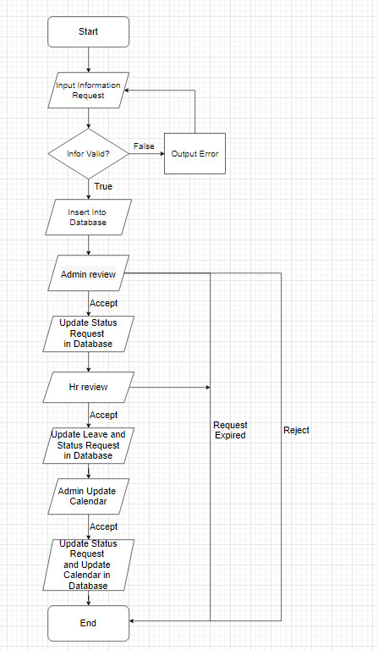

* Generate attendance monthly report

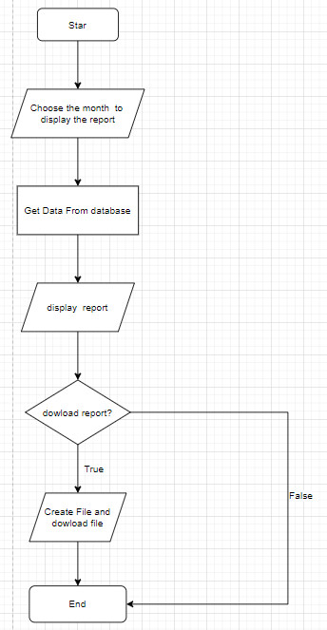

* Calculation salary

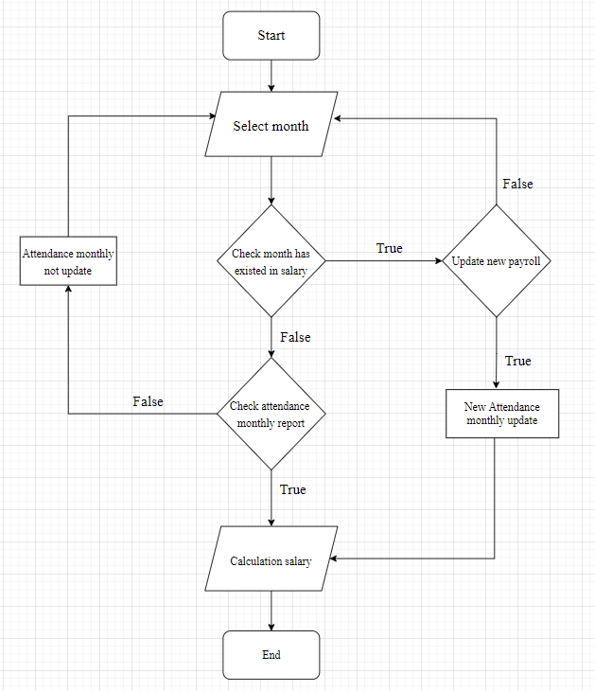

* Generate salary report

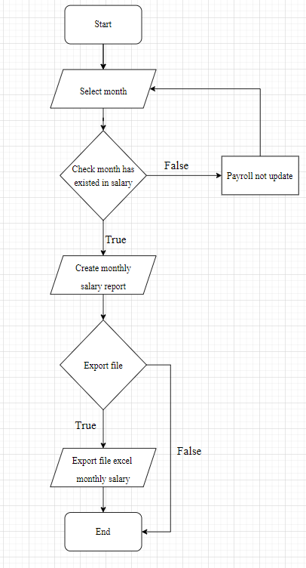

## 3. DATABASE STRUCTURE

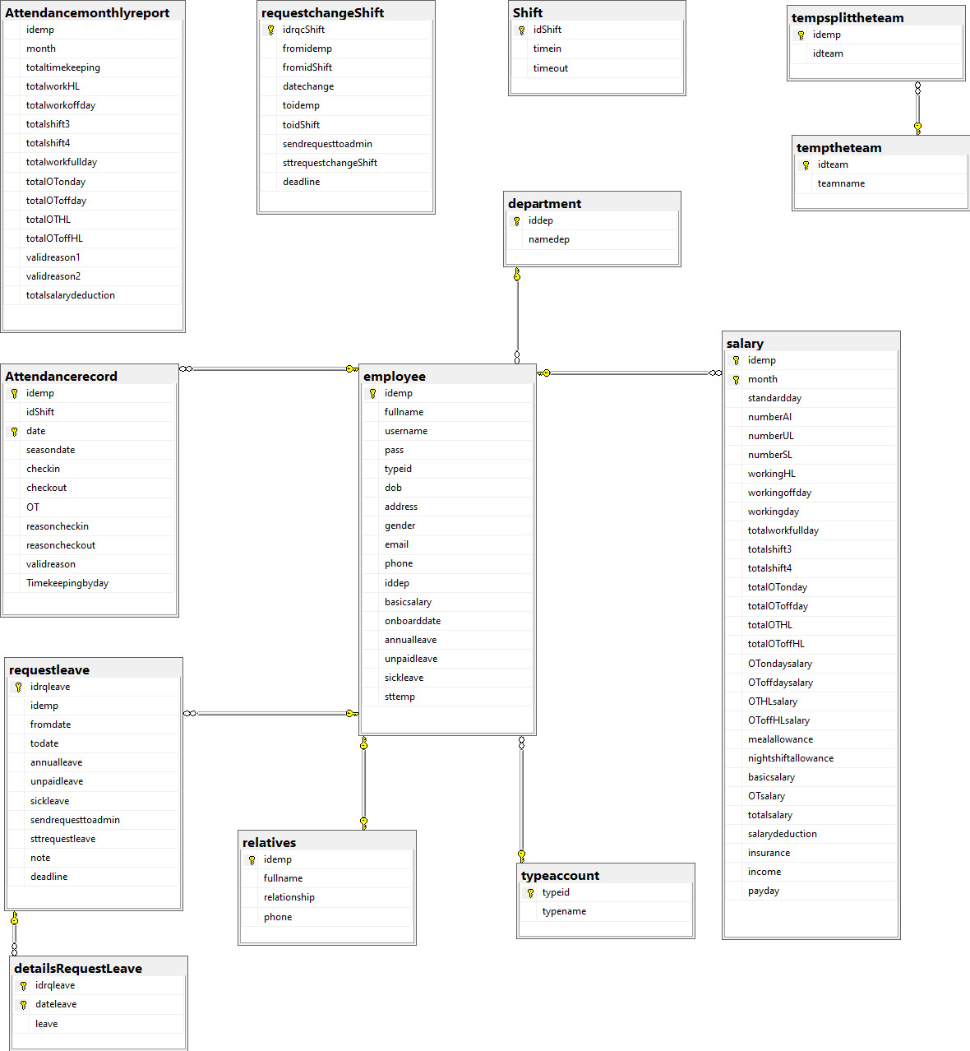

# colored rectanglecolored rectangleC**HAPTER 3: INTERFACE SNAPSHOT**

## 1. MAIN

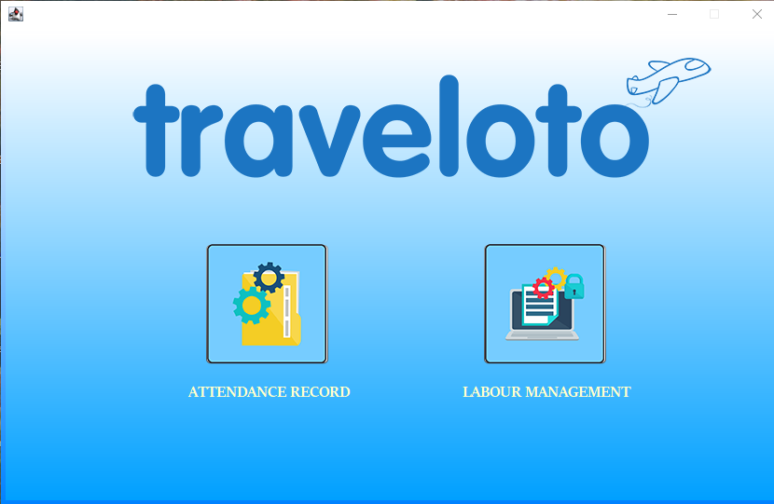

Figure 3.1. Main

## 2. ATTANDANCE RECORD

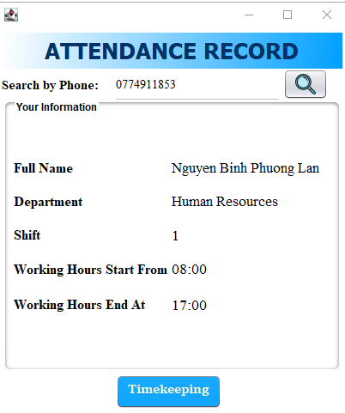

Figure 3.2. Attandance record

## 3. LOGIN

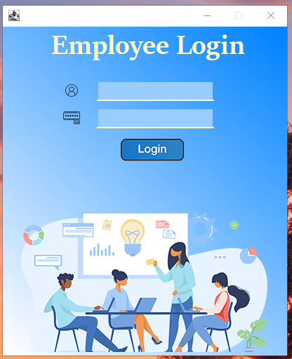

Figure 3.3. Login

## 4. CHOOSE TYPE

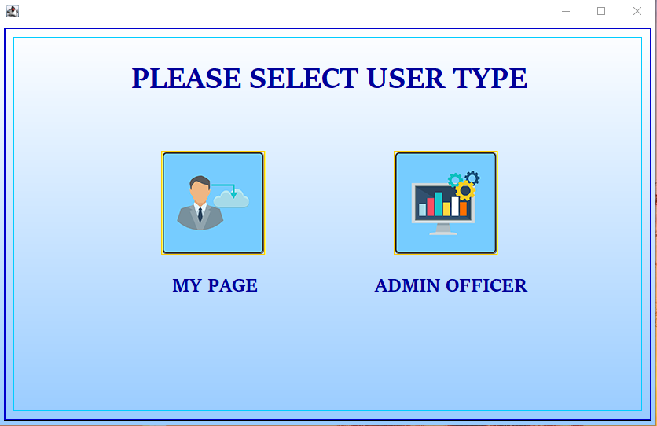

Figure 3.4.1. Choose type (Admin)

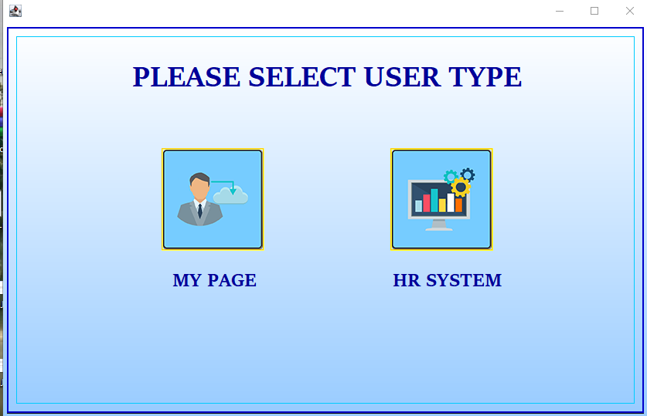

Figure 3.4.2. Choose type (HR)

## 5. ADMIN OFFICER

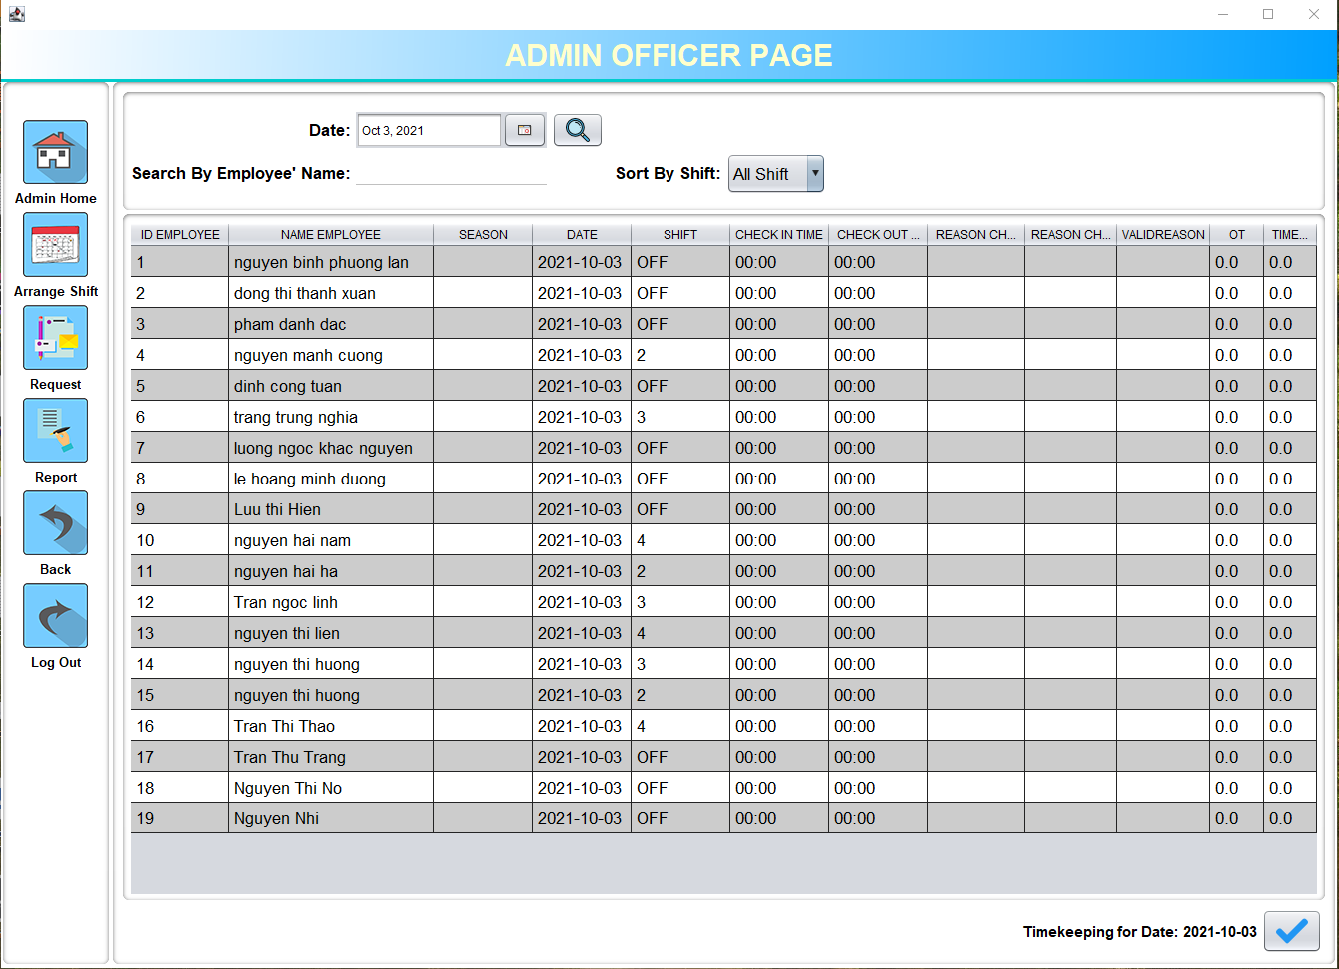

Figure 3.5. Main Admin

## 6. HUMAN RESOURCES

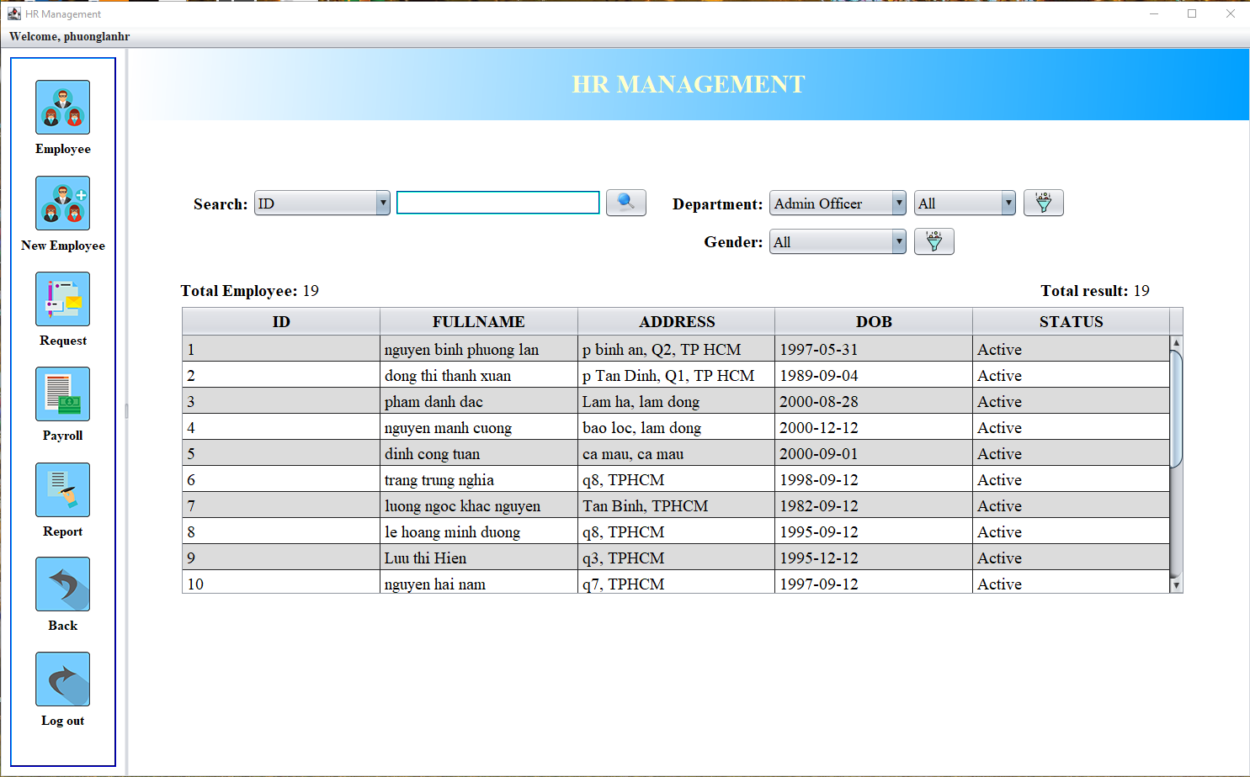

Figure 3.6. Main HR

## 7. EMPLOYEE

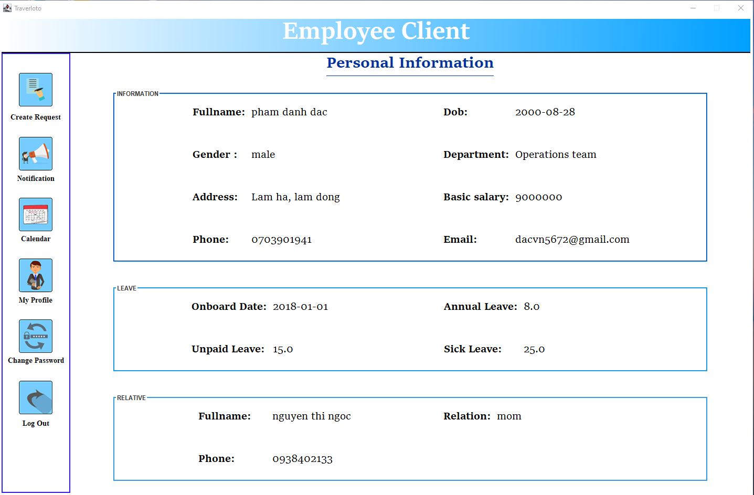

Figure 3.7. Main Employee

# colored rectanglecolored rectangleCHAPTER 4: EMPLOYEE GUIDE

## 1. MAIN

### 1.1. Description

When starting to run the application, the main page will display with 2 options: timekeeping or login to the system.

### 1.2. Design and operation

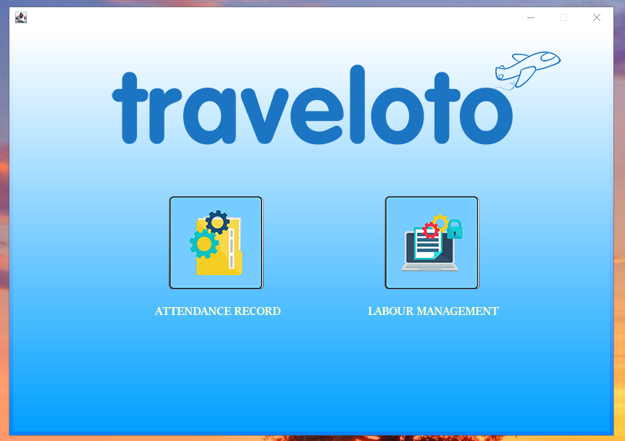

**2**

**1**

Figure 4.1. Main

|  |  |
| --- | --- |
| **Operation No.** | **Description** |
| 1 | Click button No.1 to attendance record |
| 2 | Click button No.2 to access system |

## 2. ATTENDANCE RECORD

### 2.1. Description

When click button attendance record this frame will display for employee to timekeeping. Employee can search information by number phone and the info about: name, department, shift with time-in and time-out of today work will display in below.

### 2.2. Design and operation



**1**

**2**

Figure 4.2. Attendance record

|  |  |
| --- | --- |
| **Operation No.** | **Description** |
| 1 | Click button No.1 to search info by number phone |
| 2 | Click button No.2 to check-in or check-out |

**Shift = 0:** the employee doesn't have a working shift today, but still can check-in and check-out if go to work.

1. If not yet check-in and check-out: recorded check-in time. (anytime in day)
2. If not yet check-out (already check-in): recorded check-in time. (anytime in day)
3. If already check-in and check-out: recorded check-out time. (anytime in day)

**Shitf ≠ 0**: the employee has a working shift today and the system will check if the employee has been check-in or check-out already or not.

1. Not yet recorded check-in and check-out for working shift:

* Check-in on time or ealry: successful box will display.

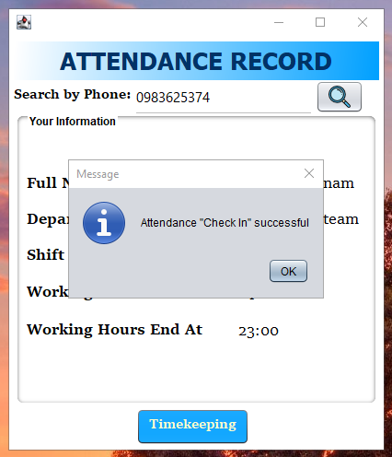

Figure 4.3. Check-in success

* Check-in late:

If employee check-in late after working time less than 2 hours, the alert box will display with 2 reason for late:

1. late work due to personal reasons
2. late work due to company work

If reason “late work due to personal reasons” has been chosen, the input reason box will display for employee input the personal reason or skip this step by click cancel and admin will update reason later.

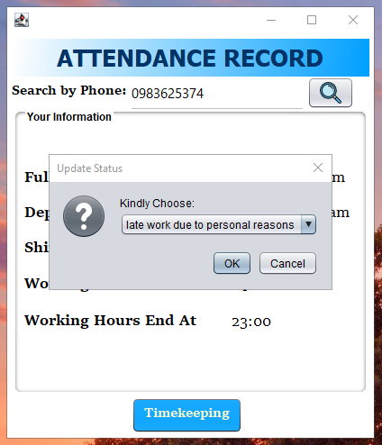 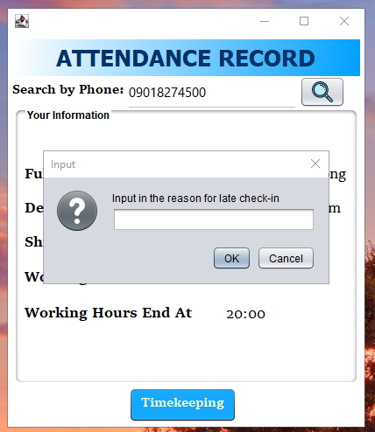

**1**

**4**

**3**

**2**

**1**

Figure 4.3. Late check-in less than 2 hours

|  |  |
| --- | --- |
| **Operation No.** | **Description** |
| 1 | Click on combo box No.1 to choose reason |
| 2 | Input field for personal reason (not mandatory) |
| 3 | Click button No.3 to update reason |
| 4 | Click button No.4 to cancel, it will be skip this step, but the check-in/check-out is not successful |

If employee check-in late after working time more than 2 hours, employee need to contact to admin for check-in or confirm for check-out early.

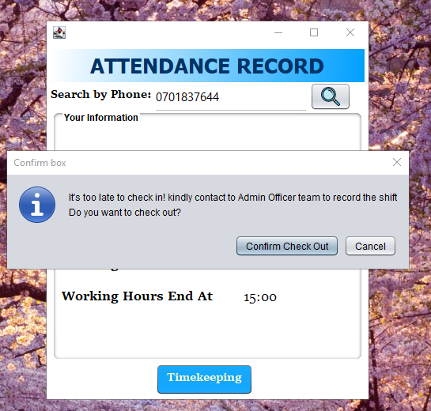 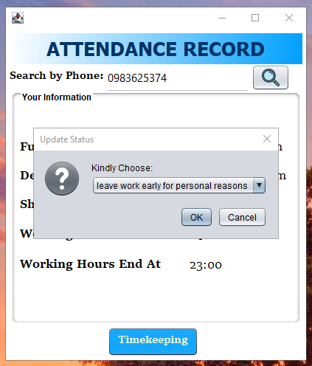

**4**

**3**

**1**

**2**

Figure 4.4. Late check-in more than 2 hours

|  |  |
| --- | --- |
| **Operation No.** | **Description** |
| 1 | Click button No.1 for confirm check-out early. Update status box will display. |
| 2 | Click button No.2 for cancel check-out early. |
| 3 | Click on combo box No.3 for choose reason check-out early.  Two reason:   1. leave work early for personal reasons 2. leave work due to company work |
| 4 | Click button No.4 for update reason.  If the reason “leave work early for personal reasons” has been chosen, the input reason box will display for employee input the personal reason or skip this step by click cancel and admin will update reason later. (detail instruction in check-out early) |

1. Not yet recorded check-out (already check-in) for working shift:

* If check-out time is more than 9 hours after check-in time: Employees can check out normally.

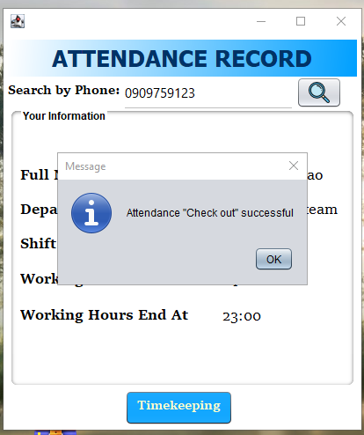

Figure 4.5. Check-out success

* If check-out time is less than 9 hours after check-in time: the alert box will display for confirm check out early with 2 reason:

1. leave work early for personal reasons
2. leave work due to company work

If reason “leave work early for personal reasons” has been chosen, the input reason box will display for employee input the personal reason or skip this step by click cancel and admin will update reason later.

If employee forget to check-out, admin will update later.

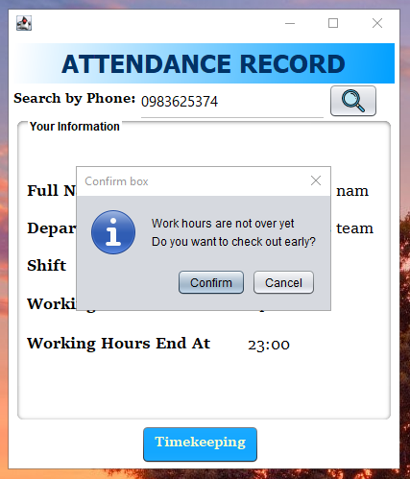 

**3**

**2**

**1**

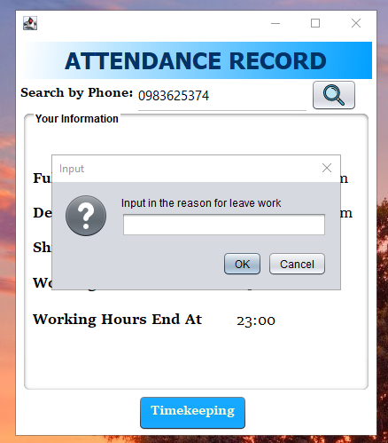

**5**

**4**

Figure 4.6. Check-out early

|  |  |
| --- | --- |
| **Operation No.** | **Description** |
| 1 | Click button No.1 for confirm check-out early |
| 2 | Click on combo box No.2 for choose reason check-out early. |
| 3 | Click button No.3 for confirm reason. |
| 4 | If the reason “leave work early for personal reasons” has been chosen, the input reason box No.4 will display to input reason. (not mandatory) |
| 5 | Click button No.5 for update reason. |
| 6 | Click button No.6 for skip this step. |

## 3. LOGIN

### 3.1. Description

On the main page, if the user selects to access “Labour Management” system, the user is required to input username and password to login.

### 3.2. Design and operation

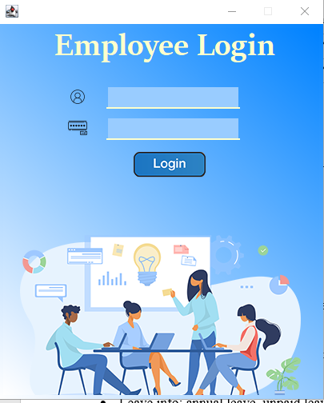

**3**

**2**

**1**

Figure 4.7. Login

|  |  |
| --- | --- |
| **Operation No.** | **Description** |
| 1 | * This field is mandatory. * This field will be checked if this username is registered and matches the password registered in the database. |
| 2 | * This field is mandatory. * This field will be checked if this password is matches the hashpass corresponding to the registered username in the database. |
| 3 | Click button No.3 to login. |

## 4. MY PROFILE

### 4.1. Description

This is default display when login employee account. This page will show all employee information include:

* Employee info: id, dob, fullname, gender, address, department, basic salary, phone, e-mail.
* Leave info: annual leave, unpaid leave, sick leave.
* Relatives info: fullname, phone, relationship.

### 4.2. Design and operation

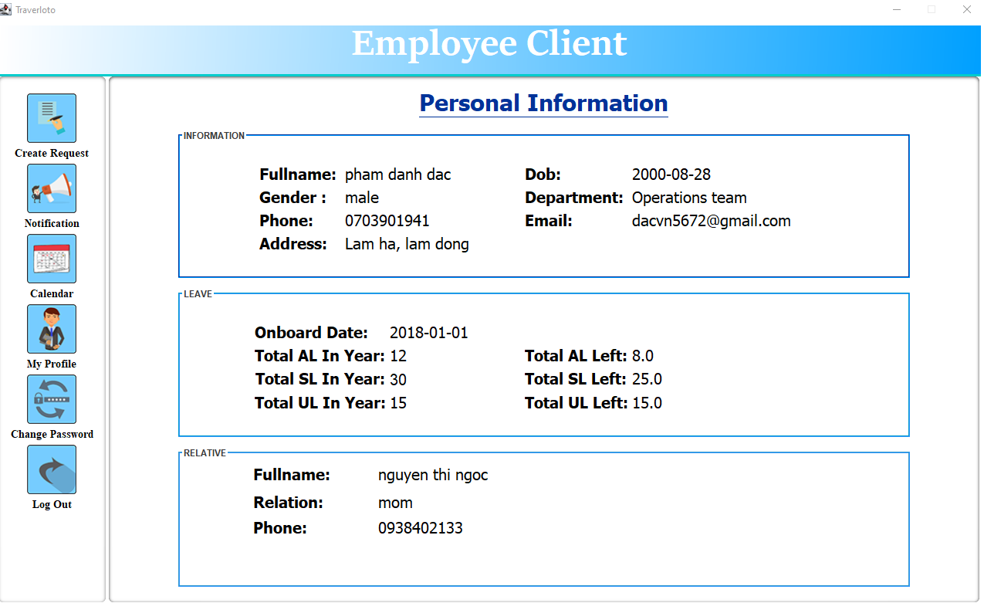

Click here

Figure 4.8. My profile

## 5. CALENDAR

### 5.1. Description

This page will display information about the employee's shift for the month. Employees can review their calendars for all working months has been arranged by the admin. They can review all woking month before to present month. The work schedule will help employees make an effective plan for their work. Work schedules also help employees arrange leave or change shifts in case they are busy.

### 5.2. Design and operation

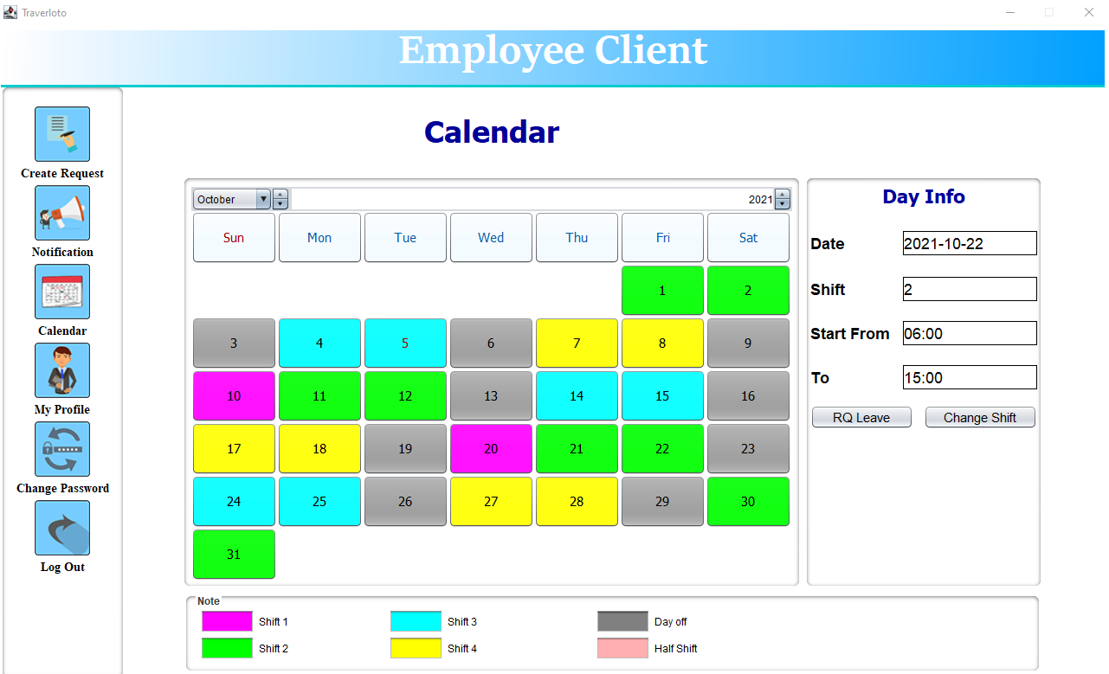

Click here

**3**

**2**

**1**

Figure 4.9. Calendar

|  |  |
| --- | --- |
| **Operation No.** | **Description** |
| 1 | Click any colored day on a calendar to view detail working shifts on the day includes the date, shift, working hour on day info field. |
| 2 | Click button No.2 for create request leave on day selected |
| 3 | Click button No.3 for create request change shift on day selected. |

## 6. CREATE REQUEST

### 6.1. Description

Create request that allows employees to create request leave and change shift requests. This function helps to manage the employee's leave as well as to arrange the work plan if an employee applies for leave or wants to change his/her shift more effective.

### 6.2. Design and operation

#### 6.2.1. Request leave

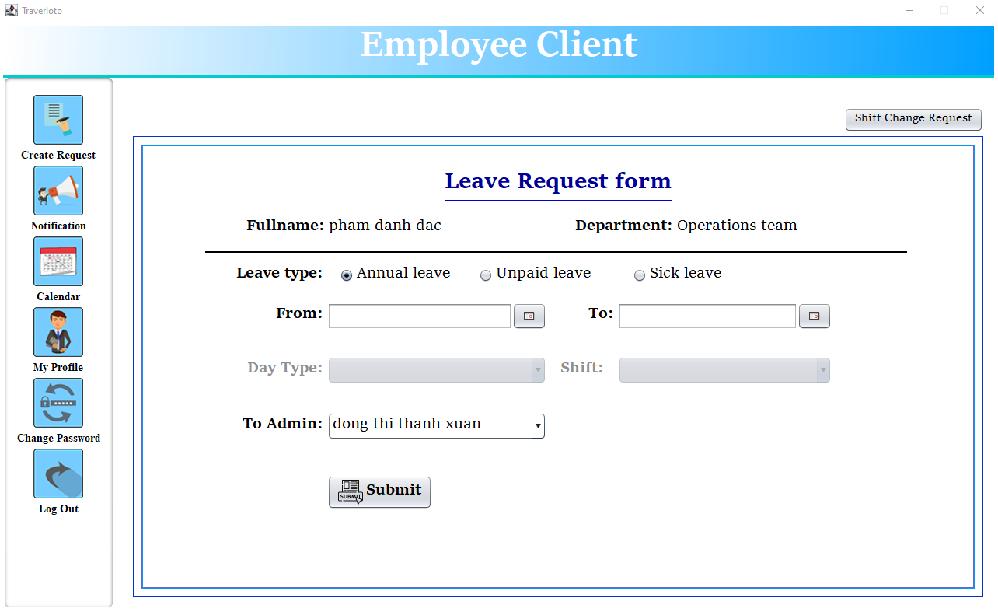

**6**

**5**

Click here

**3**

**2**

**1**

**4**

**7**

Figure 4.10.1. Leave request form (employee account)

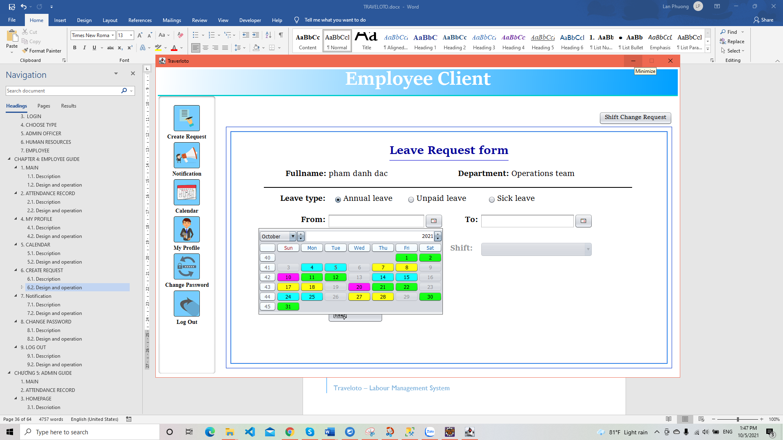

Figure 4.10.2. Choose date (employee account)

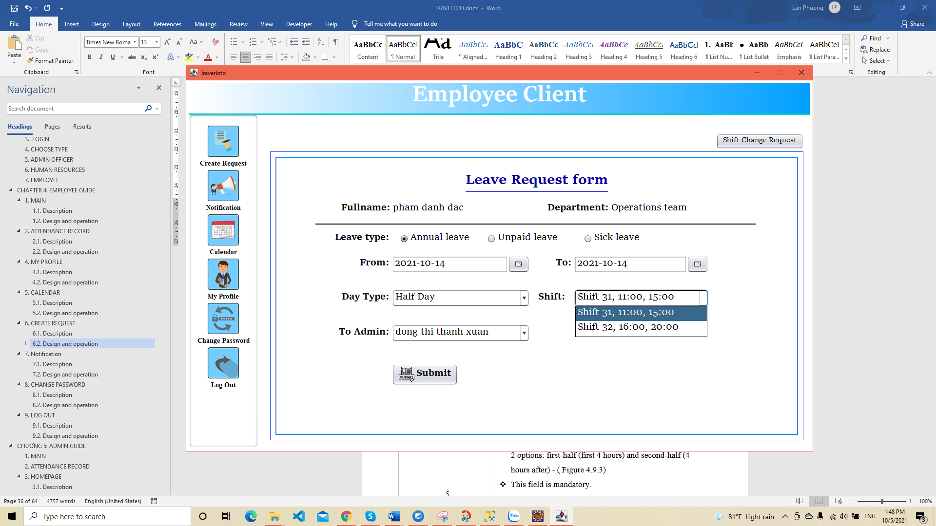

Figure 4.10.3. Choose half-day

|  |  |
| --- | --- |
| **Operation No.** | **Description** |
| 1 | * Choose radio button for type of leave. * Three type: annual leave, unpaid leave, sick leave. |
| 2 | * This field is mandatory. * Only select colored days on the calendar (before 15 days to present and the day that arranged shift) - ( Figure 4.9.2) |
| 3 | * This field is mandatory. * Must be the day after the start date. |
| 4 | * This field will display if the start date and end date in the same date.(normally in hide) * Day type has 2 options: full day and half day. * The shift will enable if the half day has been chosen with 2 options: first-half (first 4 hours) and second-half (4 hours after) - ( Figure 4.9.3) |
| 5 | * This field is mandatory. * Select admin to submit the request (admins currently have shifts). If submitted after 5 pm or on a day off of an administrative shift (Saturday, Sunday), to admin box will display admin to go to work on the nearest day. |
| 6 | Submit the request form to the admin. (status of request: new request (No.0)) |
| 7 | Move to page of creating change shift requests. |

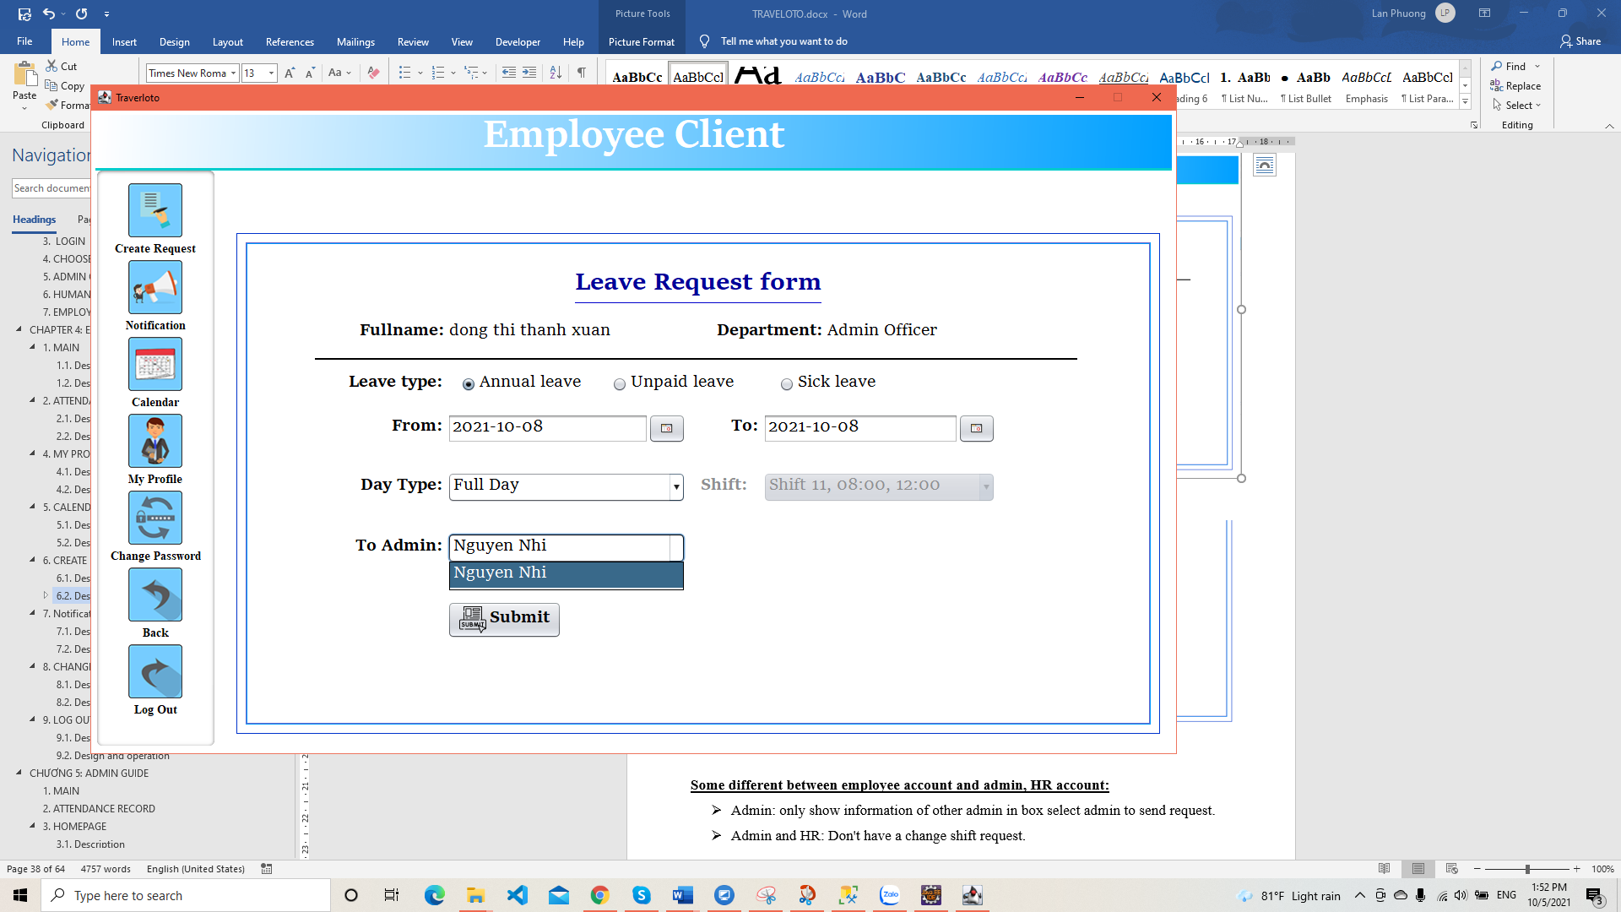

Figure 4.10.4. Leave request form (admin account)

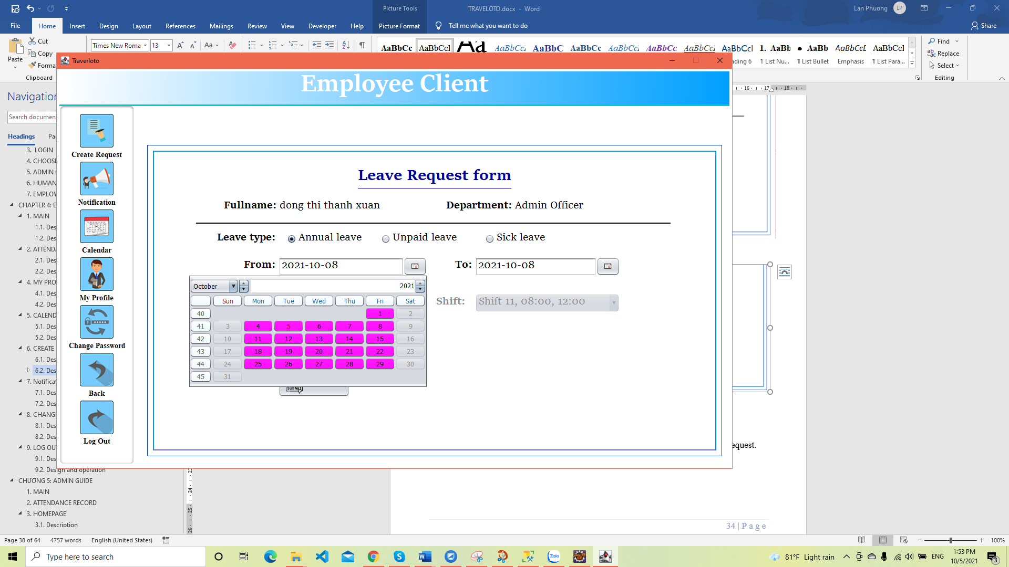

Figure 4.10.5. Chosse date (admin & HR account)

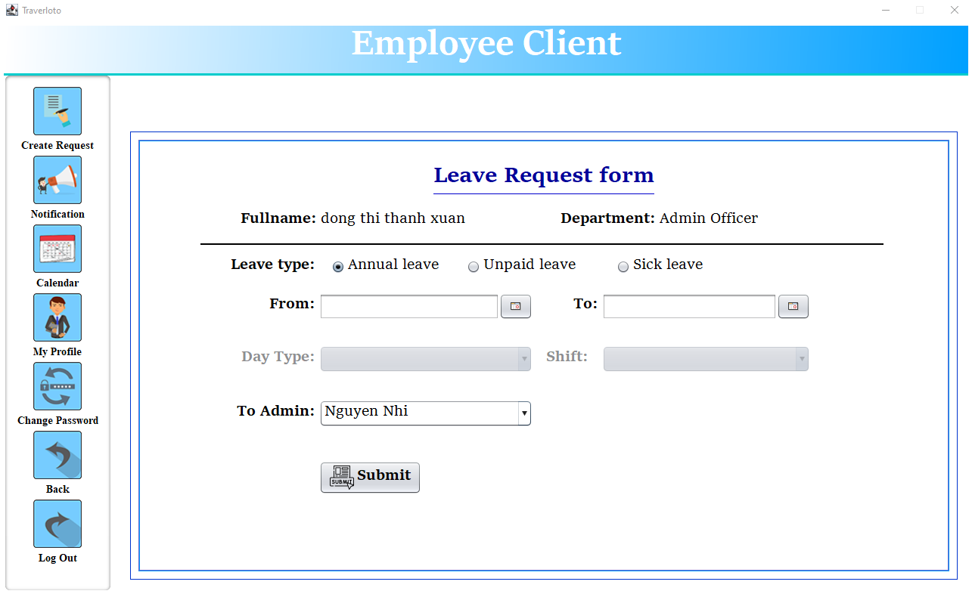

Figure 4.10.6. Only leave request (admin & HR account)

**Some different between employee account and admin, HR account:**

* Admin: only show information of other admin in box select admin to send request. ( Figure 4.10.4)
* Admin and HR: Don't have a change shift request.

**Some constraints when creating the request leave:**

* The employee can't request leave for off day or the day that has been accepted for half day leave.
* Unable to submit the day of leave has been accepted (excluding the date request was denied or the day out of approving deadline: 3 days from create request day).
* Deadline (expired day of request):
* If fromdate is days before current date or 1 day after current date, request expiration is 7 days from creation date.

For example: creation date is October 4, fromdate are all dates before October 5, including October 5. then the deadline is 7 days from October 4 meaning the expiration date is October 10.

* If fromdate is 2 to 7 days after current date (creation date), then the expiration date is fromdate.

For example: creation date is October 4, fromdate from October 5 to October 10, the deadline is October 5 to October 10 respectively).

* If fromdate is 8 days after the current date (creation date) then the expiration date is 7 days from creation date.

For example: creation date is October 4, fromdate is October 11 (after 8 days from request creation date), then deadline is October 10.

#### 6.2.2. Request change shift (only employee account)

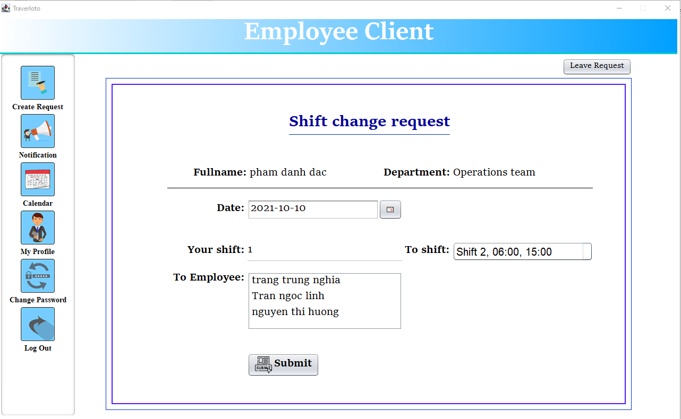

**3**

**5**

**4**

**2**

**1**

**6**

Figure 4.11.1. Shift change request form

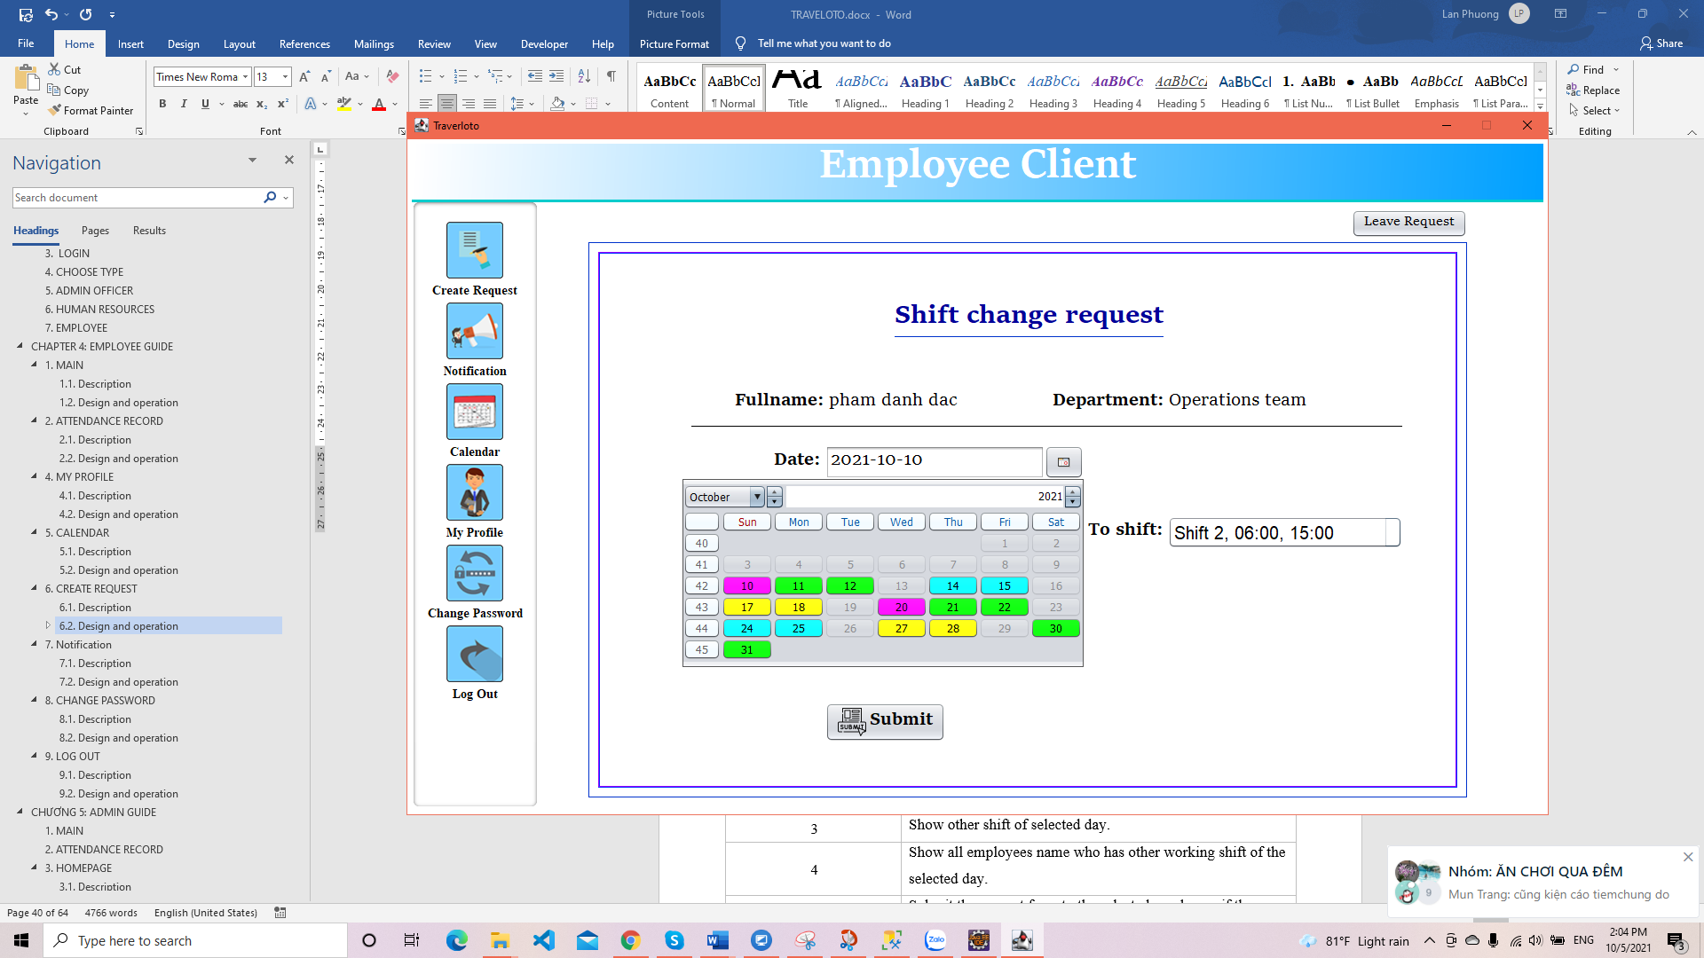

Figure 4.11.2. Choose date

|  |  |
| --- | --- |
| **Operation No.** | **Description** |
| 1 | * This field is mandatory. * Only select colored days on the calendar (the day that has working shift, excluding the day has been submitted for half-day leave) - ( Figure 4.10.2) |
| 2 | Show working shift of the selected day. |
| 3 | Show other shift of selected day. |
| 4 | Show all employees name who has other working shift of the selected day. |
| 5 | Submit the request form to the selected employee, if the employee accepted, request will send to admin to confirm. |
| 6 | Move to page of creating leave requests. |

**Some constraints when creating the change shift request:**

Employees are allowed to submit 4 days in advance excluding today, so the deadline is 3 days from creation day (excluding today).

For example, on October 4, the employee submits change shift request for October 8 (or the days after that), the deadline is still on October 7.

## 7. Notification

### 7.1. Description

The notification will display notices about employee leave requests, shift change requests and other employee shift change requests sent to. The notification will assist employees in tracking whether their request for leave or shift change has been approved or not.

### 7.2. Design and operation

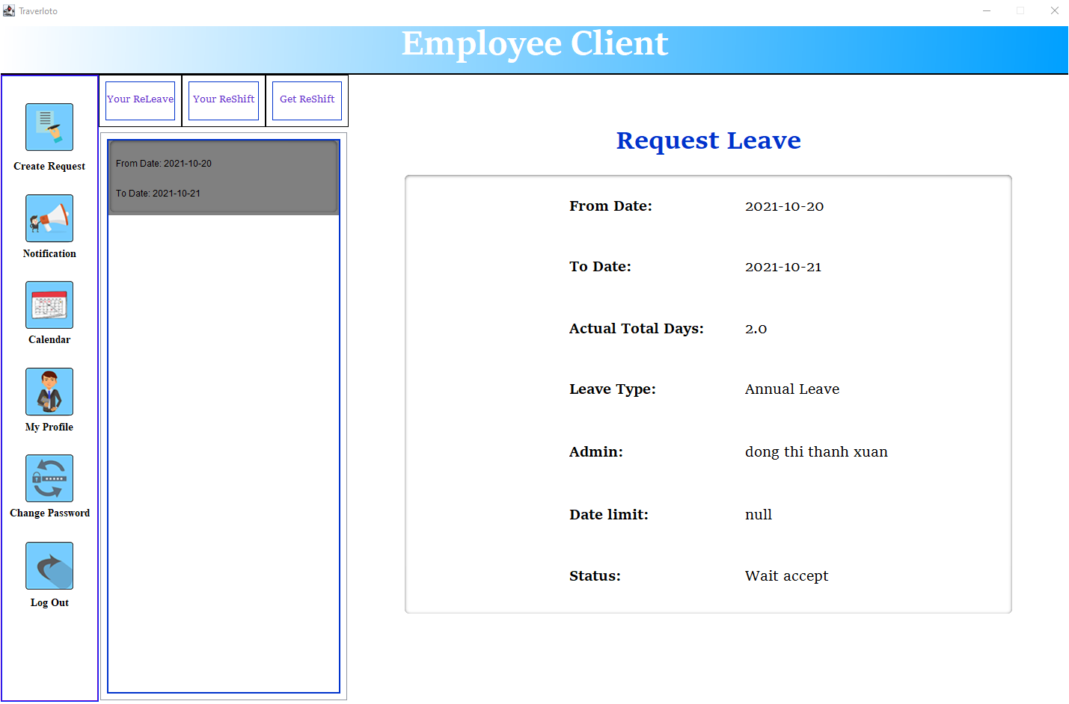

Click here

**4**

**3**

**2**

**1**

Figure 4.12.1. Notification – Request leave (employee account)

|  |  |
| --- | --- |
| **Operation No.** | **Description** |
| 1 | Click button No.1 for show request leave. (Figure 4.11.1) |
| 2 | Click button No.2 for show request change shift. (Figure 4.11.2) |
| 3 | Click button No.3 for show information of request change shift from other employee sent to. (Figure 4.11.3) |
| 4 | Click button No.4 for show detail of request. |

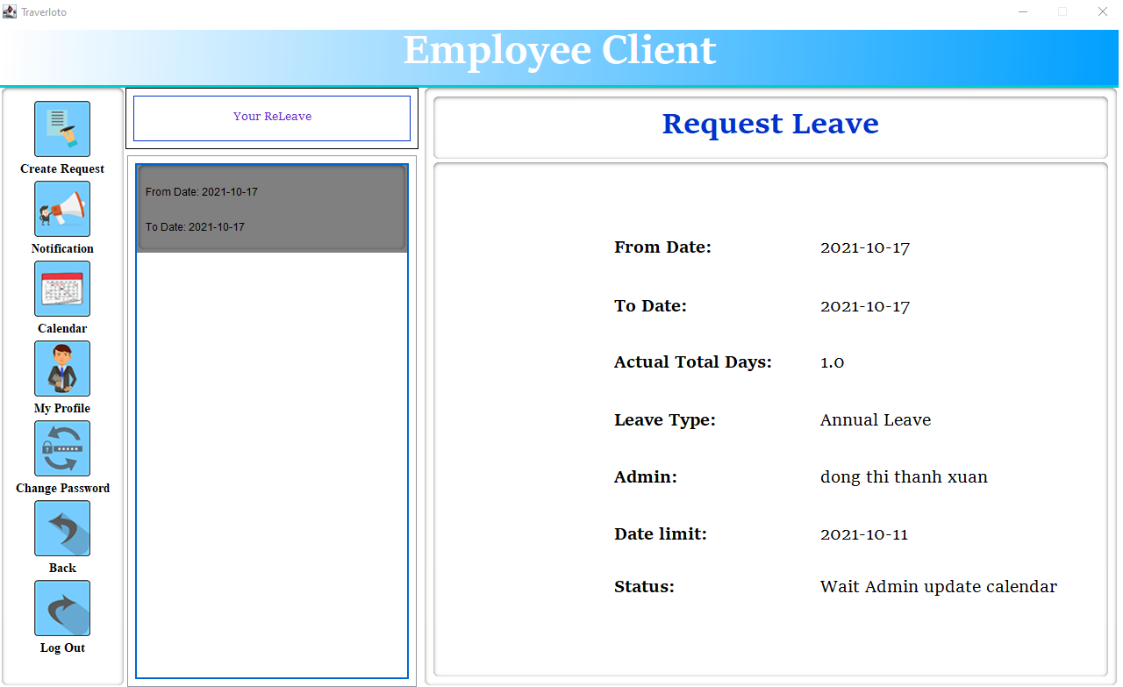

Figure 4.12.2. Notification – Request leave (admin and HR account) – only have request leave

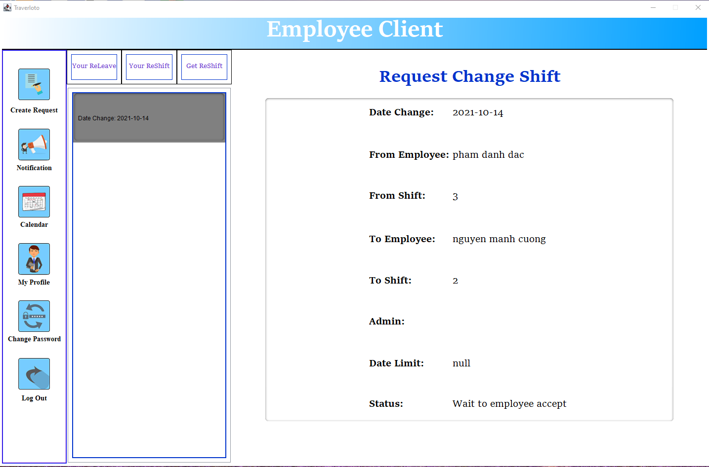

Figure 4.12.3. Notification - Request change shift

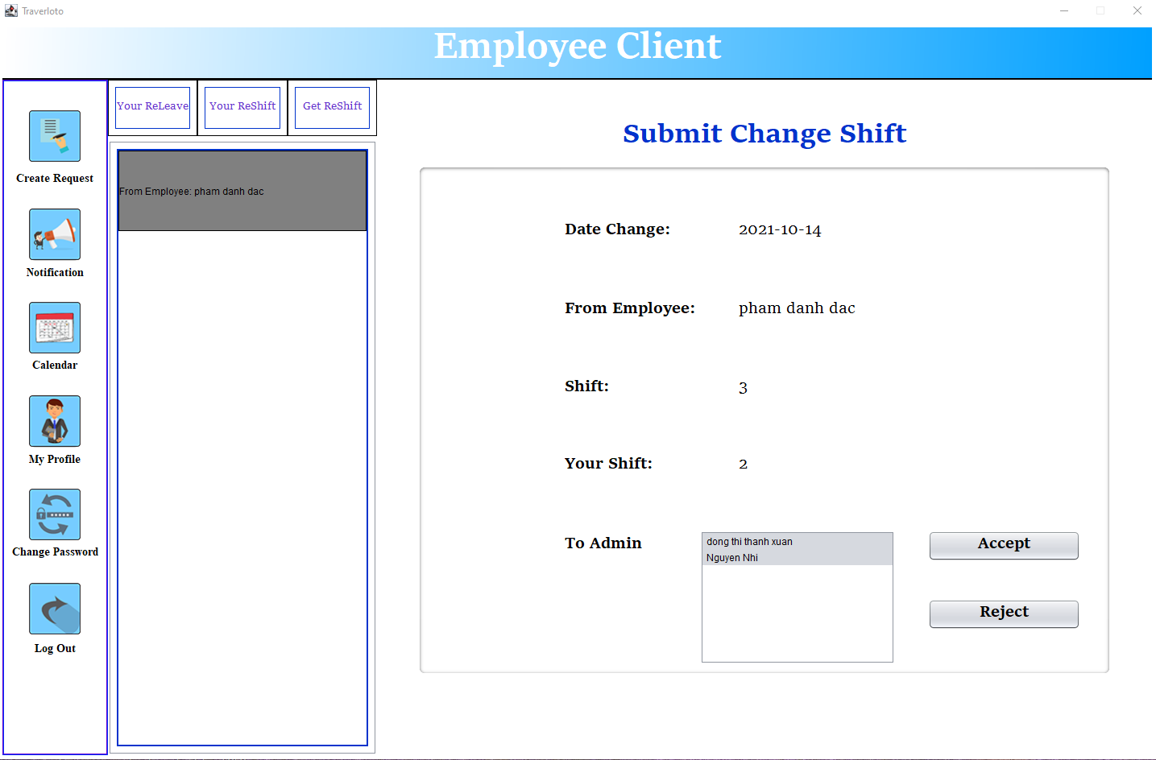

**2**

**1**

**3**

Figure 4.12.4. Notification - Request change shift from other employee sent to.

|  |  |
| --- | --- |
| **Operation No.** | **Description** |
| 1 | Click button No.1 for select admin to send request. |
| 2 | Click button No.2 for send request. |
| 3 | Click button No.3 for refuse the request. |

## 8. CHANGE PASSWORD

### 8.1. Description

Employees can change another password to use to login to the system.

### 8.2. Design and operation

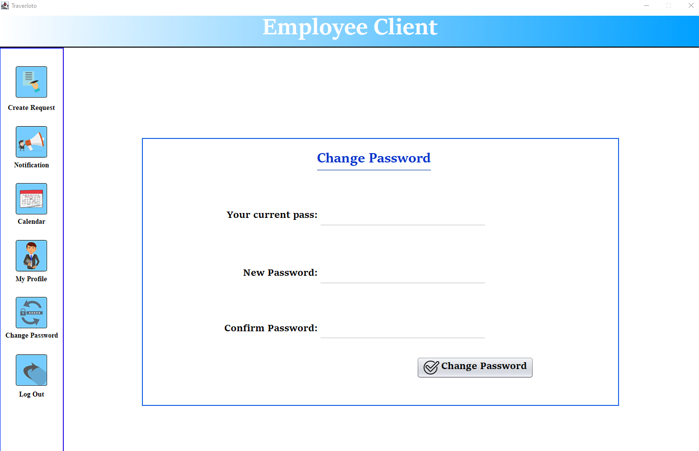

Click here

**2**

**3**

**4**

**1**

Figure 4.12. Change password

|  |  |
| --- | --- |
| **Operation No.** | **Description** |
| 1 | Input current password. |
| 2 | Input new password (must at least 6 char and at least: one digit, one lower, one upper alpha char, one special char and does not contain space, tab) |
| 3 | Input new password again to confirm. |
| 4 | Click button No.4 to confirm chang password. |

## 9. LOG OUT

### 9.1. Description

Employee can log out and back to main page after using.

For the interface of admin and hr, in addition to the log out button, there is also a button to return to the user type selection page to be able to enter the management system.

### 9.2. Design and operation

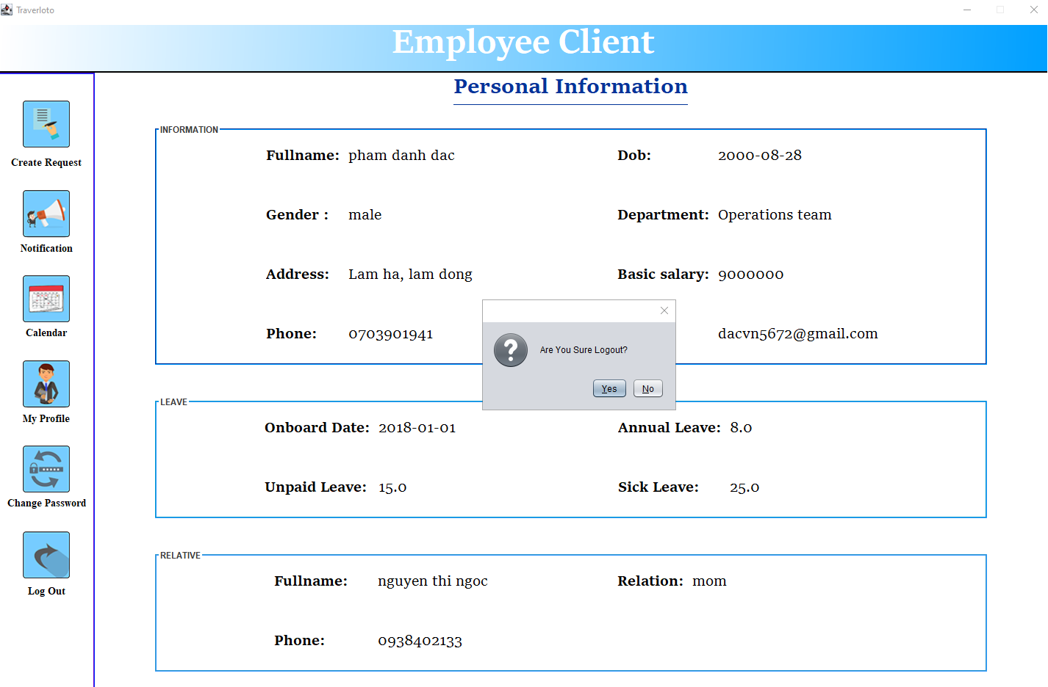

Click here

**1**

**2**

Figure 4.13.1. Logout (employee account)

|  |  |
| --- | --- |
| **Operation No.** | **Description** |
| 1 | Click button No.1 for log out system |
| 2 | Click button No.2 for cancel log out. |

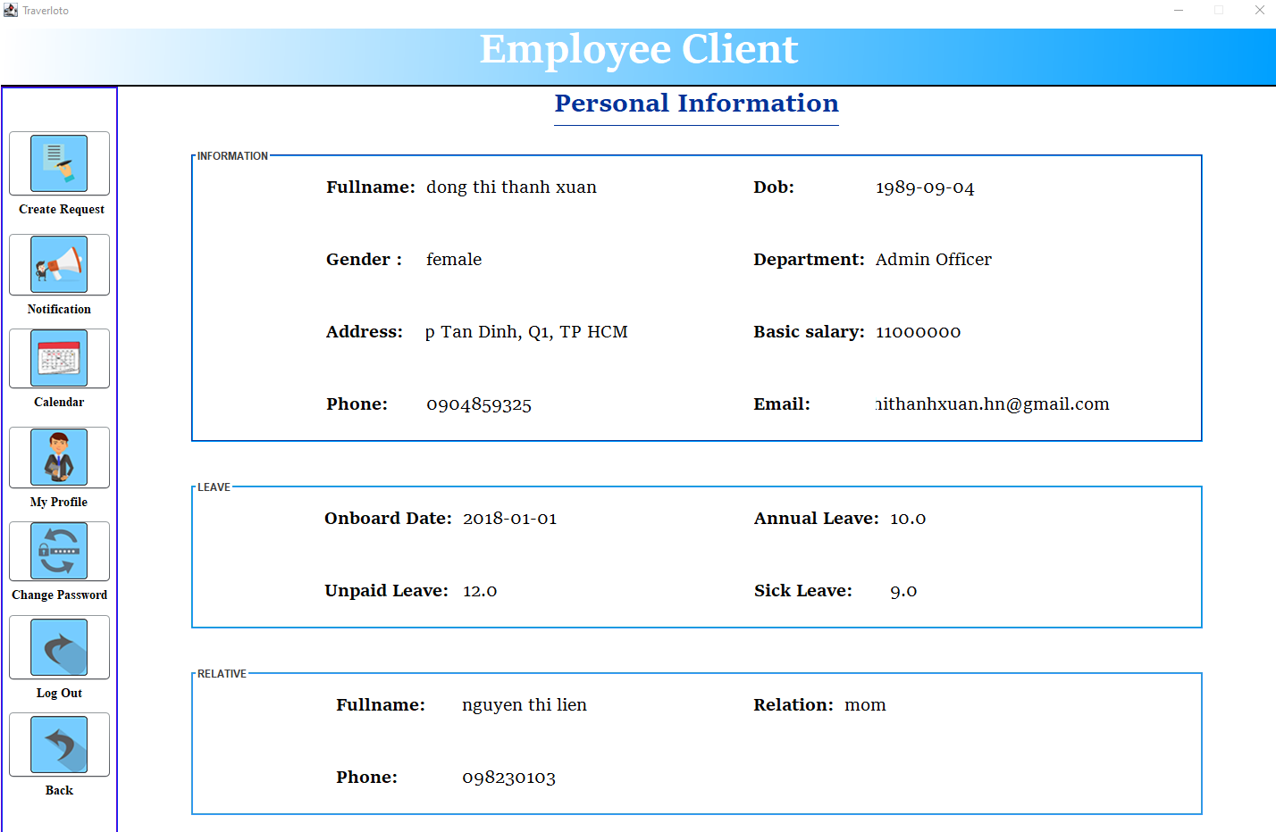

**1**

**2**

Figure 4.13.2. Logout (admin & HR account)

|  |  |
| --- | --- |
| **Operation No.** | **Description** |
| 1 | Click button No.1 for log out system |
| 2 | Click button No.2 for back to select user type. |

# colored rectanglecolored rectangleCHƯƠNG 5: ADMIN GUIDE

## 1. MAIN

Same features as employee account - See instruction in section 1-Chapter 4: Employee guide

## 2. ATTENDANCE RECORD

Same features as employee account - See instruction in section 2-Chapter 4: Employee guide

## 3. LOGIN

Same features as employee account - See instruction in section 3-Chapter 4: Employee guide

## 4. HOMEPAGE

### 4.1. Description

At the homepage, the admin will monitor and manage the daily attendance of employees. The admin can review daily attendance of employee and update information effectively.

### 4.2. Design and operation

After logging in, the user type selection page will display.

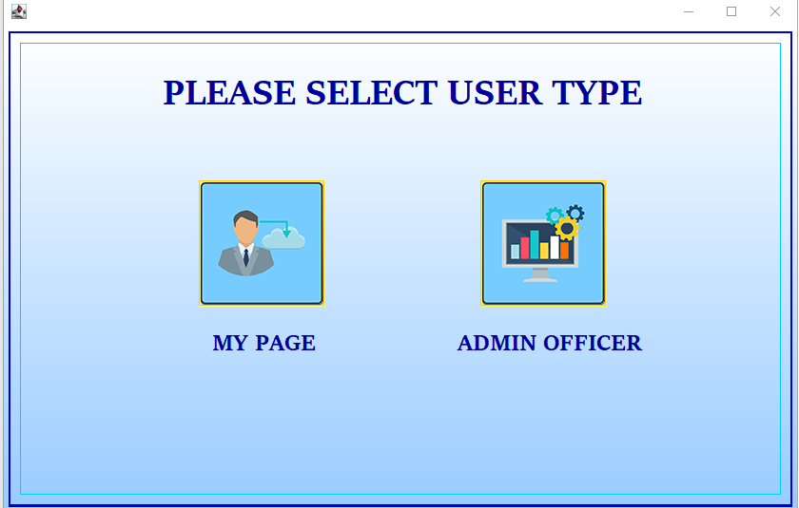

Click here

Figure 5.1. Select user type

When access admin system, homepage will show list all employee has working shift on today. Right click on row for more option.

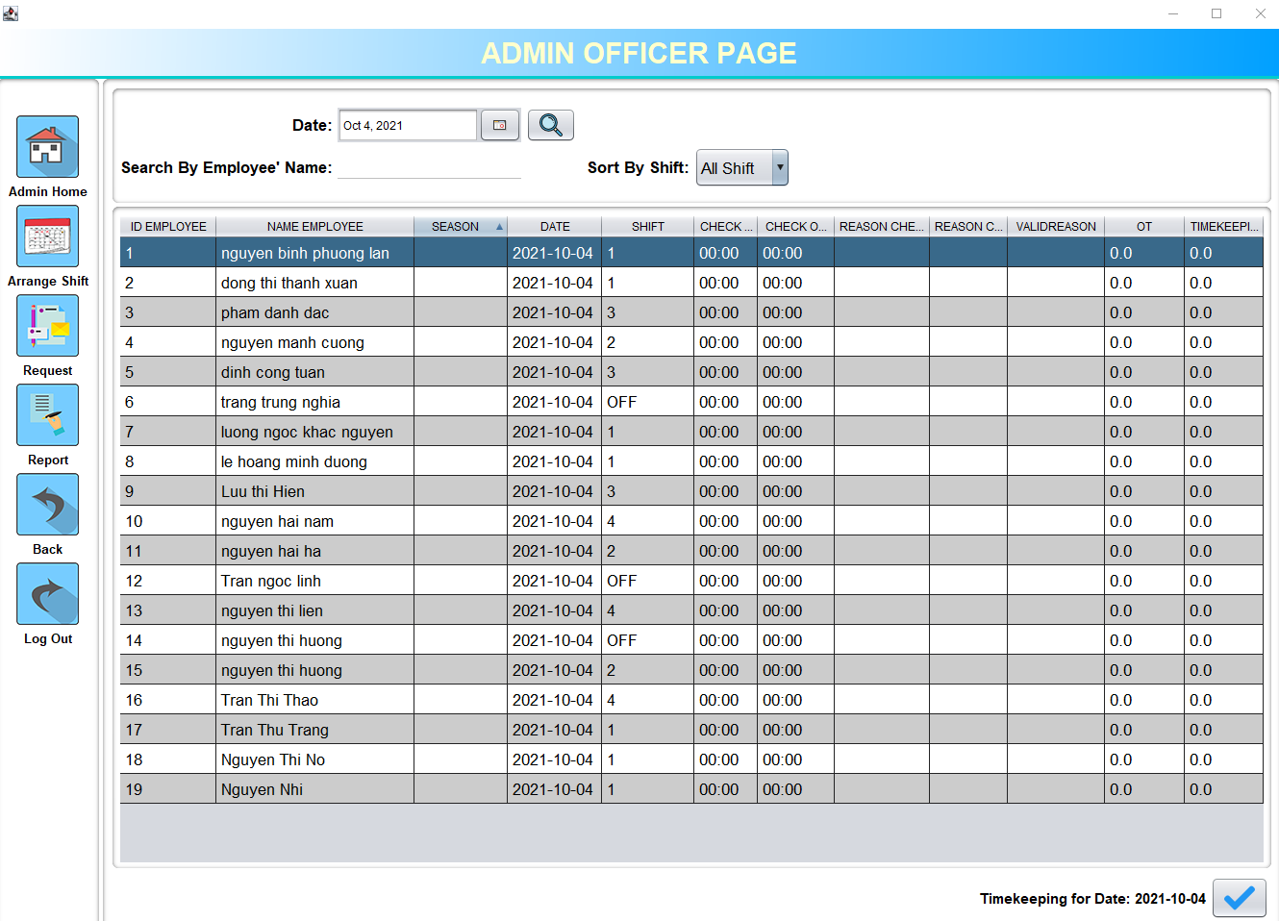

Click here

**3**

**2**

**1**

Figure 5.1.1. Homepage

|  |  |
| --- | --- |
| **Operation No.** | **Description** |
| 1 | Click button No.1 for search employee by date. |
| 2 | Click button No.2 for search employee by name (select shift befor search). |
| 3 | Sort employee by working shift. (Figure 5.1.2.) |

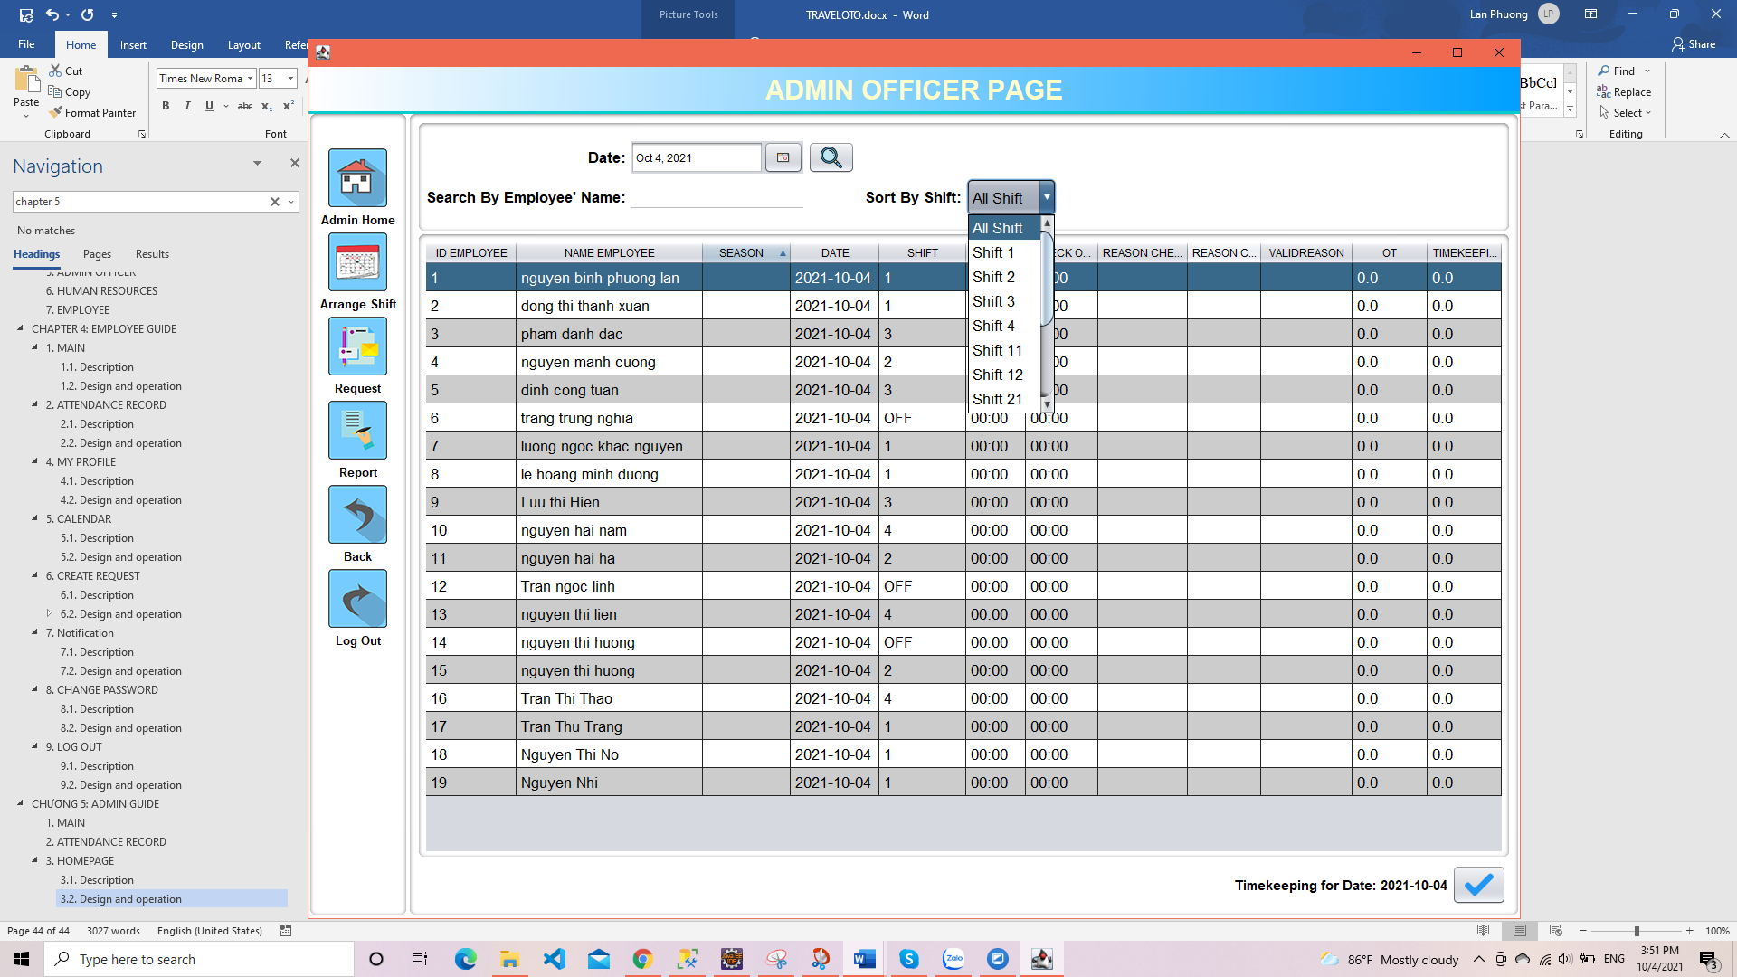 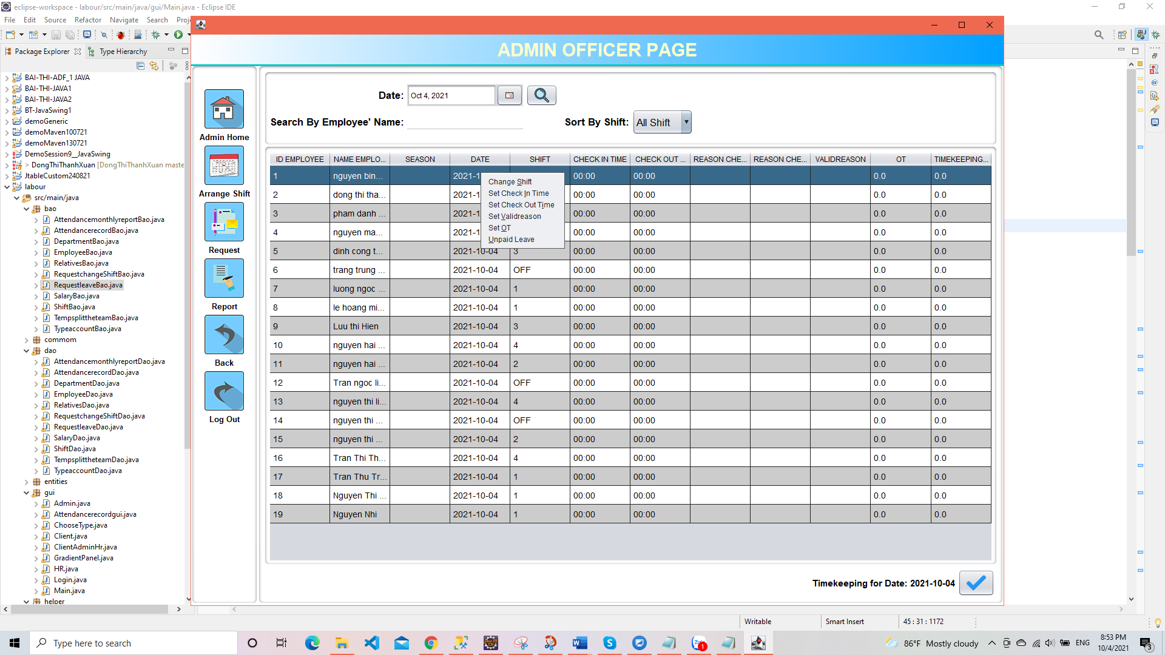

**6**

**4**

**5**

**3**

**2**

**1**

Figure 5.1.2. Select shift Figure 5.1.3. Right click on selected row

|  |  |
| --- | --- |
| **Operation No.** | **Description** |
| **1**  **Change Shift** | Update new shift ( in case unscheduled leave). |
| **2**  **Set Check-in time** | Update check-in time (right format required and sooner than check-out time), if employee doesn't have shift or overtime on the today, admin couldn't set check-in time.    After update, reason for late check-in require to select with 2 option:    If invalid reason has been selected, input reason will display for update personal reason (not mandatory). |
| **3**  **Set Check-out time** | Update check-out time(right format required), if employee doesn't have shift or overtime on the today, admin couldn't set check-in time.    After update, reason for late check-in require to select with 2 option:    If invalid reason has been selected, input reason will display for update personal reason (not mandatory). |
| **4**  **Set valid reason** | If input reason for check-in or check-out has been skipped (leave blank), admin can not update valid reason. |
| **5**  **Set overtime** | Admin can only arrange overtime not exceeding 4 hours in a day if employees has a shift on day, no more than 12 hours if employees hasn't shift on day and the total overtime in the month does not exceed 40 hours. |
| **6**  **Unpaid leave** | When an employee intentionally leaves without notice (via email, phone, app for admin): a dialog box will appear for admin to confirm whether this is an unpaid leave or not.    If confirmed, it will automatically create a request leave with the season is unpaid leave. Then admin and HR will handle like normal requests. |

 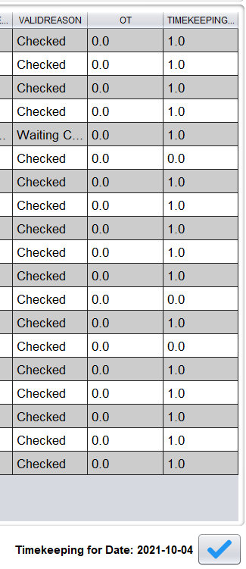

Click here

Figure 5.1.4. Before click button Figure 5.1.5. After click button

When click on button, the system will update the employee's workday into the attendance record. Update 1 working day for employees whose shift is 1, 2, 3, 4 and 0 working day for employees whose shift is off . For the remaining cases, it will be counted as 0.5 working days and the valid reason column will also be updated.

**Valid reason:** the basis for deduction of wages if the employee does not comply with the hours when going to work.

* Accept work reason: not counted as being late.
* Accept personal reason:
* 5 times or less: not counted as being late.
* more than 5 times but less than 10 times: deducted 200.000VND from net salary.
* more than 10 times: deducted 500.000VND from net salary.
* Do not accept personal reason: deducted 500.000VND from net salary/1 times.

## 5. ARRANGE SHIFT

### 5.1. Description

Admin will divide all employees of operation department into 5 groups and randomly arrange shifts for employees in each group. Following month's shift will be arranged at least 1 week in advance and in this 1 week will not allow arranging shift again, but allow for arranging shift for one month later.

### 5.2. Design and operation

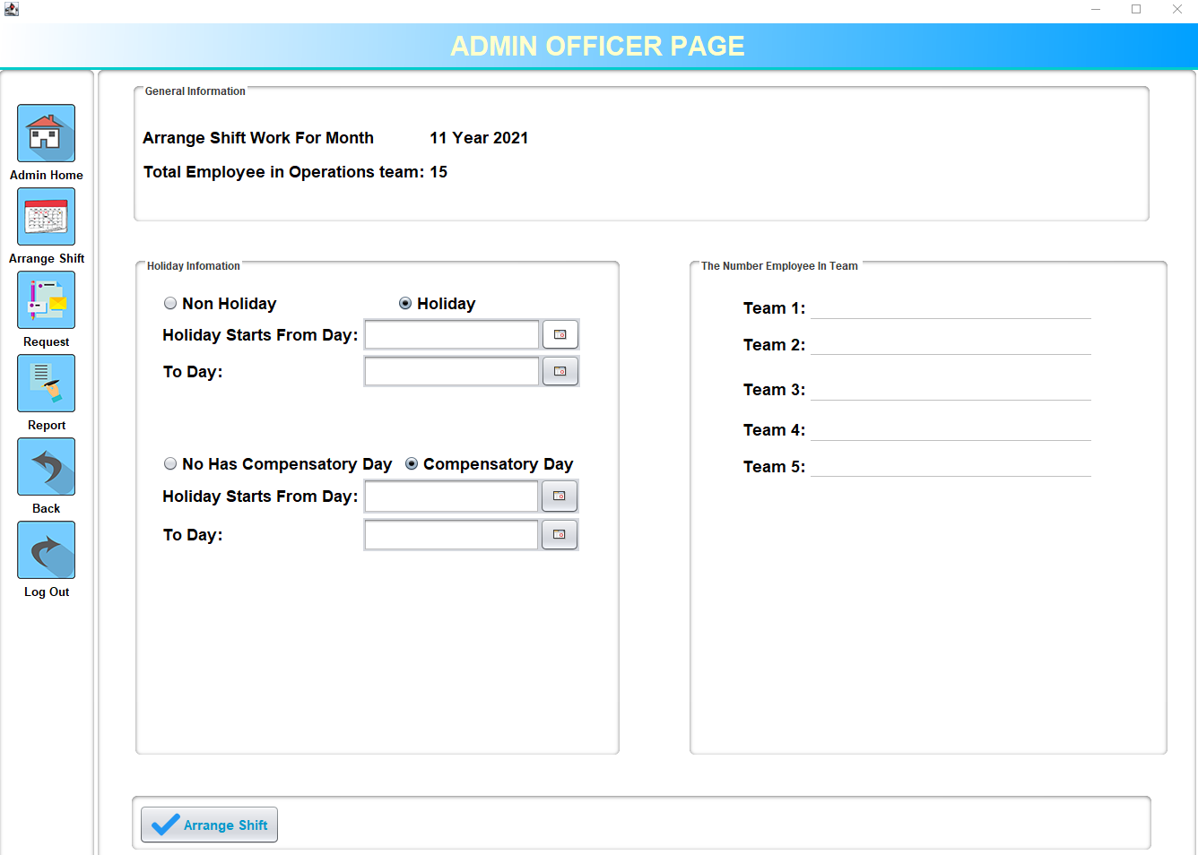

Click here

**4**

**3**

**2**

**1**

Figure 5.2. Arrange shift

|  |  |
| --- | --- |
| **Operation No.** | **Description** |
| 1 | Click choose radio holiday if month has holiday and select holiday on calendar. |
| 2 | Click choose radio compensatory day if month has compensatory day and select compensatory day on calendar. |
| 3 | Input number employee in each team, the total number of employees must be equal to the number of employees in the operation department. |
| 4 | Click on button No.4 to arrange randomly shift for each team. If click on button again, a box alert will show up to let you know if you want to arrange shift again or not.  Random shift: Each group will have a fixed work schedule for each month with random shifts. For example, if an employee works 1st shift today, they may work 2nd shift tomorrow. |

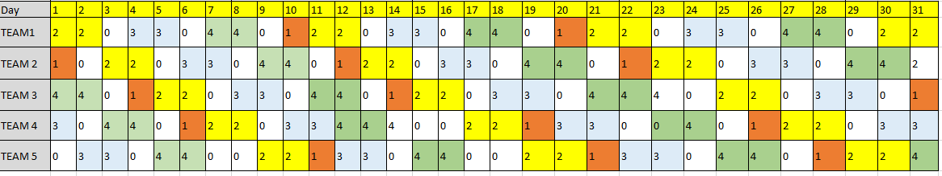

Figure 5.3. Random shift

Employees will be randomly assigned to a team as long as the total number of people on a team is the number entered. Shifts are arranged by the team. Different teams have different work schedules. The shifts of each team change from day to day.

## 6. REQUEST

### 6.1. Description

Admin will receive all notices regarding shift change or layoff at this page. The application will help admins manage employees' working time more effectively, minimizing lack of labour force.

### 6.2. Design and operation

#### 6.2.1. Request change shift

This tab will show all list of request change shift send from employee.

When a request to change shifts is created and accepted by two employees changing shifts, the request will be sent to the admin with the status is “New request”.

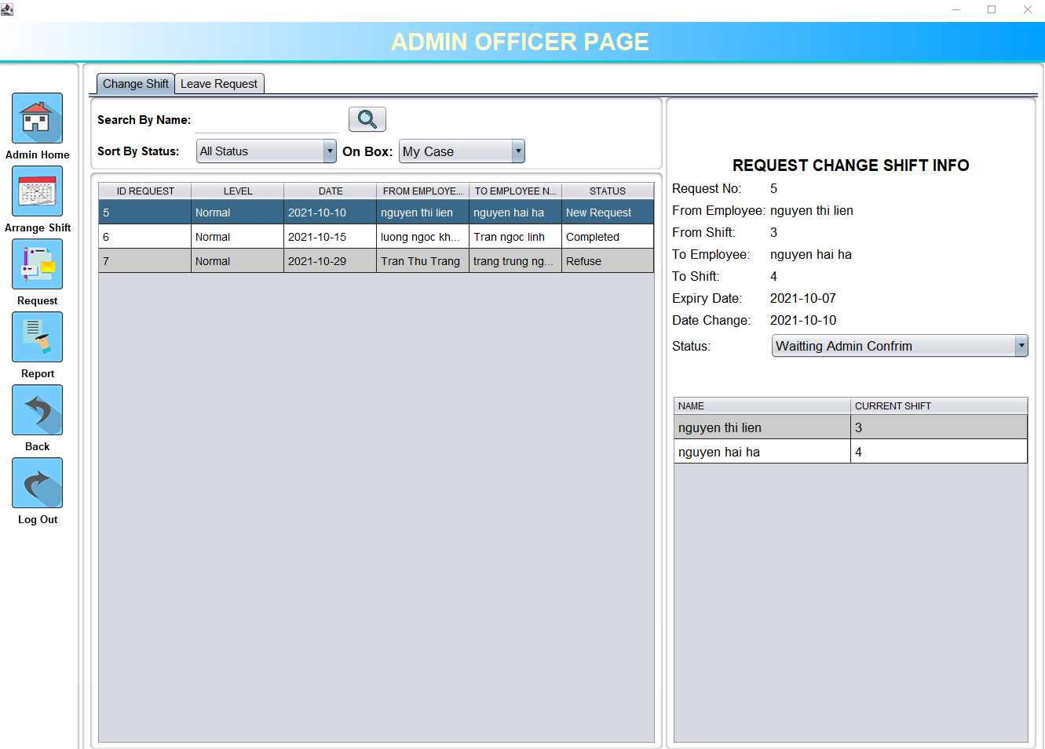

Click here

**6**

**5**

**4**

**3**

**2**

**1**

Figure 5.4. Request change shift

|  |  |
| --- | --- |
| **Operation No.** | **Description** |
| 1 | Search request by employee’s name. |
| 2 | Sort request by status:   1. Waiting admin confirm: new request 2. Confirm: completed shift change 3. Refuse: admin refused |
| 3 | Sort by request send to admin. |
| 4 | Show status of request, admin will select status: |
| 5 | This table will show information about two employee’s shift request to change shift.  Right-click to go to the homepage to update the new shift if the admin accepts the request. |
| 6 | Show lists of leave request. |

#### 6.2.2. Request leave

This tab will show all lists of request leave and status of the request.

**Leave application process:**

* When a request leave is created, the request will be sent to the admin with the status is “New request”.
* If the admin accepts the leave request, the admin will select an employee from the HR department to send leave information to update the employee's leave.
* After the HR update is complete, the information will be sent back to the admin to update on the employee's work schedule (status: “Waiting update calendar”).
* After admin finishes updating the work schedule, the request status is completed.

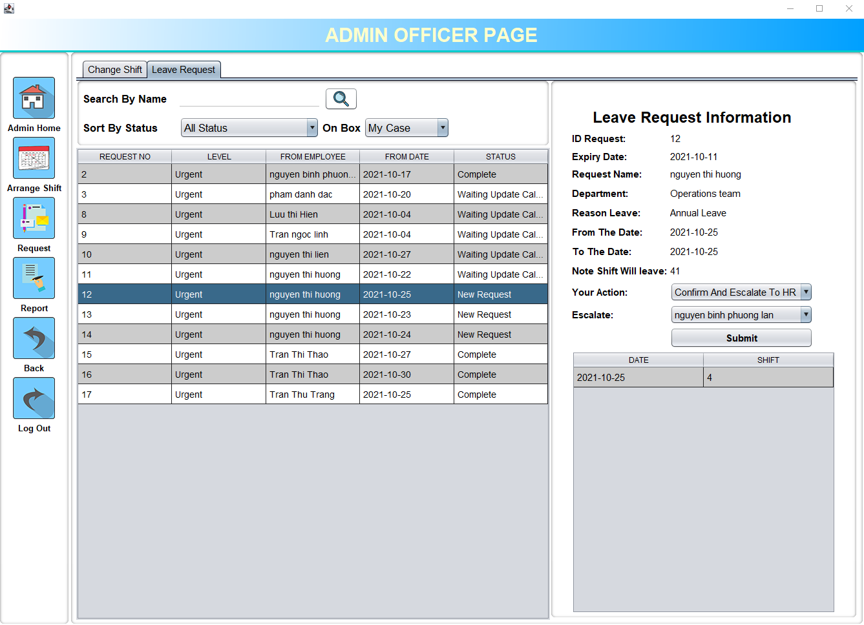

Click here

**7**

**6**

**5**

**4**

**3**

**2**

**1**

Figure 5.5. Request leave

|  |  |
| --- | --- |
| **Operation No.** | **Description** |
| 1 | Search request by employee’s name. |
| 2 | Sort request by status:   1. Cancel: admin canceled the request 2. Complete: request has been accepted. 3. New request: new request created. 4. Waiting update calendar: After HR updates the employee's leave, the information is sent back to the admin to update on the system. |
| 3 | Sort by request sends both to admin or HR. |
| 4 | If status of request is: New request, this action box will display with 2 options:   1. Confirm and escalate to HR: send request’s info to HR department to update employee’s leave. 2. Reject this request     If status of request is: Waiting update calendar, this action box will display with 2 options:   1. Waiting update calendar: HR has updated the employee’s leave and wait for admin to update the work schedule. 2. Update in calendar: admin updates the working schedule. |
| 5 | When action “Confirm and escalate to HR” has been selected, the names of the employees of the HR department will appear for the admin to choose to send information. |
| 6 | Click on button No.6 to accept an action for request. |
| 7 | Right-click to go to the homepage to review the employee’s work calendar. |

## 7. REPORT

### 7.1. Description

The report will statistics all information related to employee timekeeping monthly. There is 3 type of reports:

* Attendance monthly report: Summarize monthly working days of employees such as total working days, total tardy days, total overtime days, etc.
* Employee's detail report: Summarize each employee's attendance day by day such as specific time to go to work every day, reason for being late, etc.
* Attendance monthly detail report: Summarize details of all employees' working time in a month such as check-in time, check-out time. etc

### 7.2. Design and operation

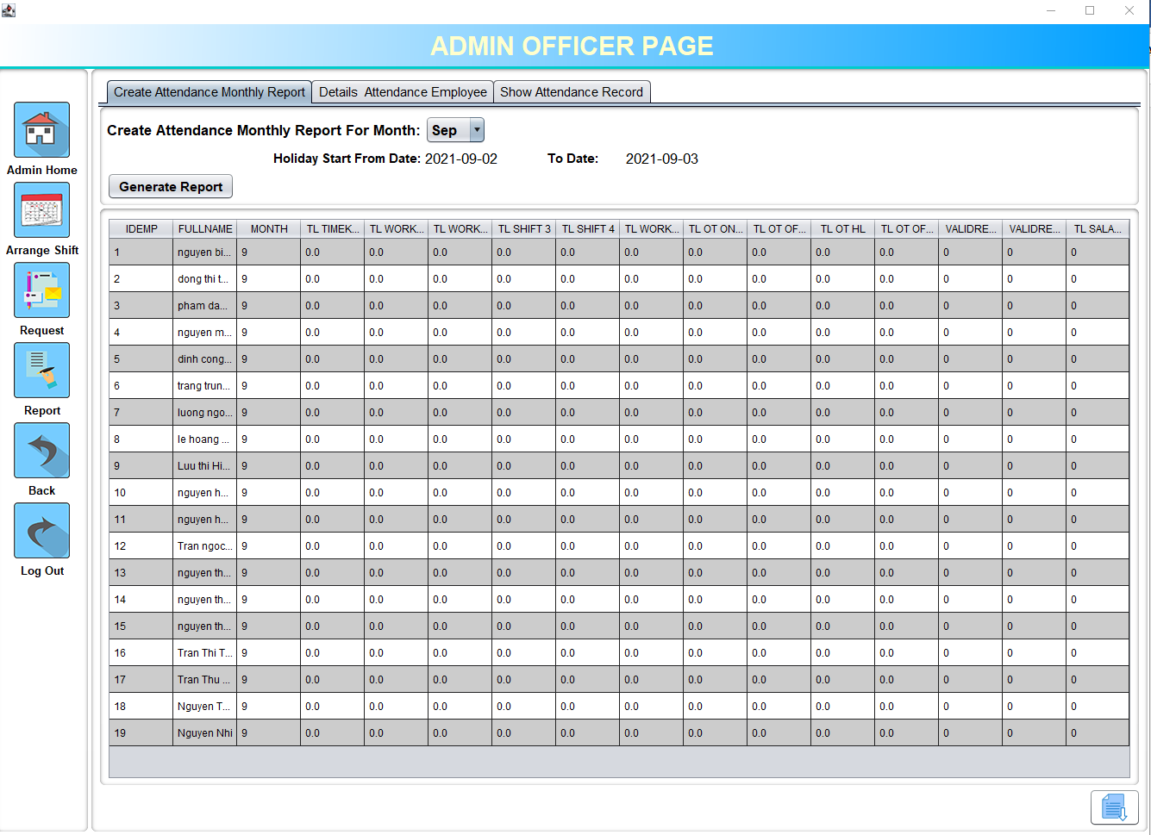

**6**

**7**

**5**

**4**

**3**

**2**

**1**

Click here

Figure 5.6. Create attendance monthly report

|  |  |
| --- | --- |
| **Operation No.** | **Description** |
| 1 | Tab create attendance monthly report. |
| 2 | Tab detail attendance employee report. |
| 3 | Tab show attendance record. |
| 4 | Select month to generate attendance record. |
| 5 | Generate attendance record. |
| 6 | Show information about holiday or compensator in month. |
| 7 | Export excel file of attendance monthly report. |

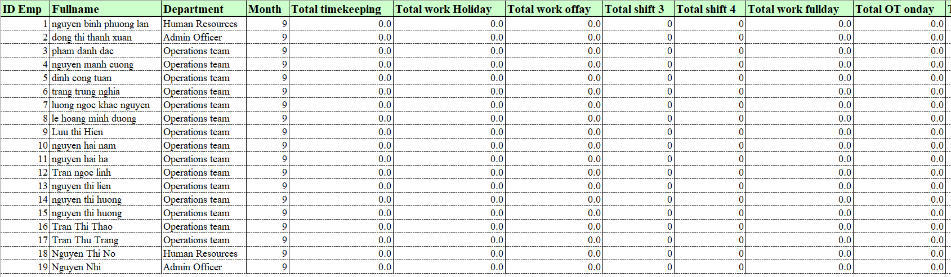

Figure 5.7. File excel of attendance monthly report

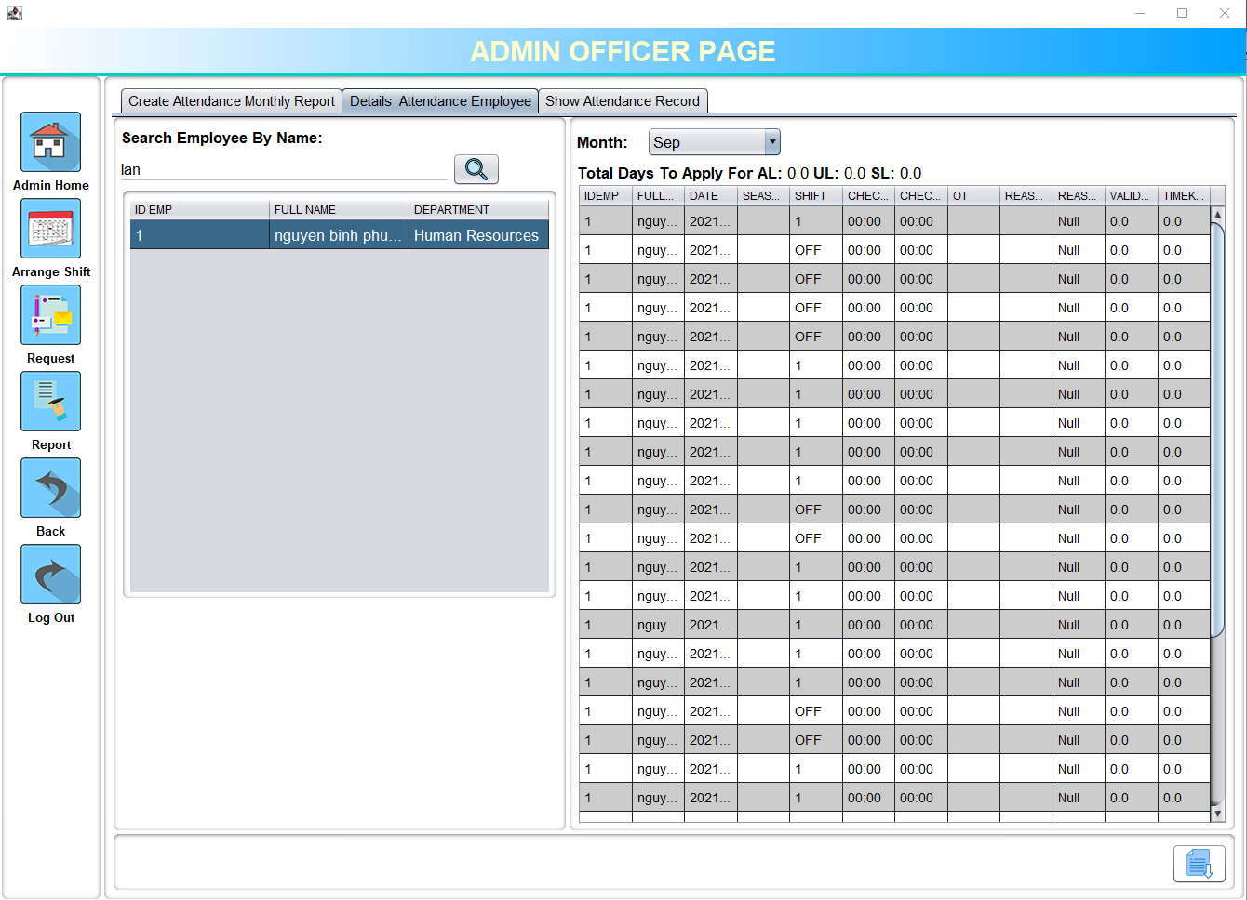

**3**

**2**

Click here

**1**

Figure 5.8. Detail attendance employee

|  |  |
| --- | --- |
| **Operation No.** | **Description** |
| 1 | Search employee’s attendance record by name. |
| 2 | Select month to show employee’s attendance record. |
| 3 | Export excel file of detail employee’s attendance monthly report. |

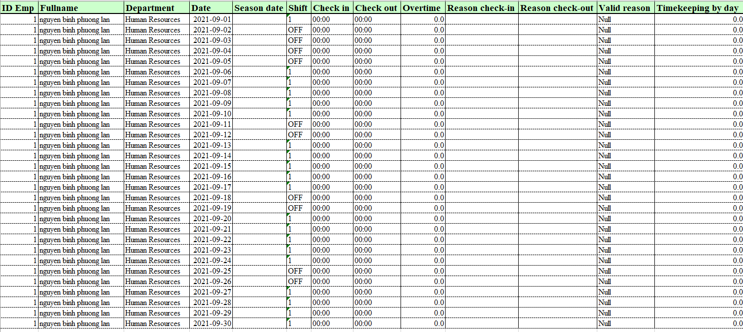

Figure 5.9. File excel of detail employee’s attendance monthly report

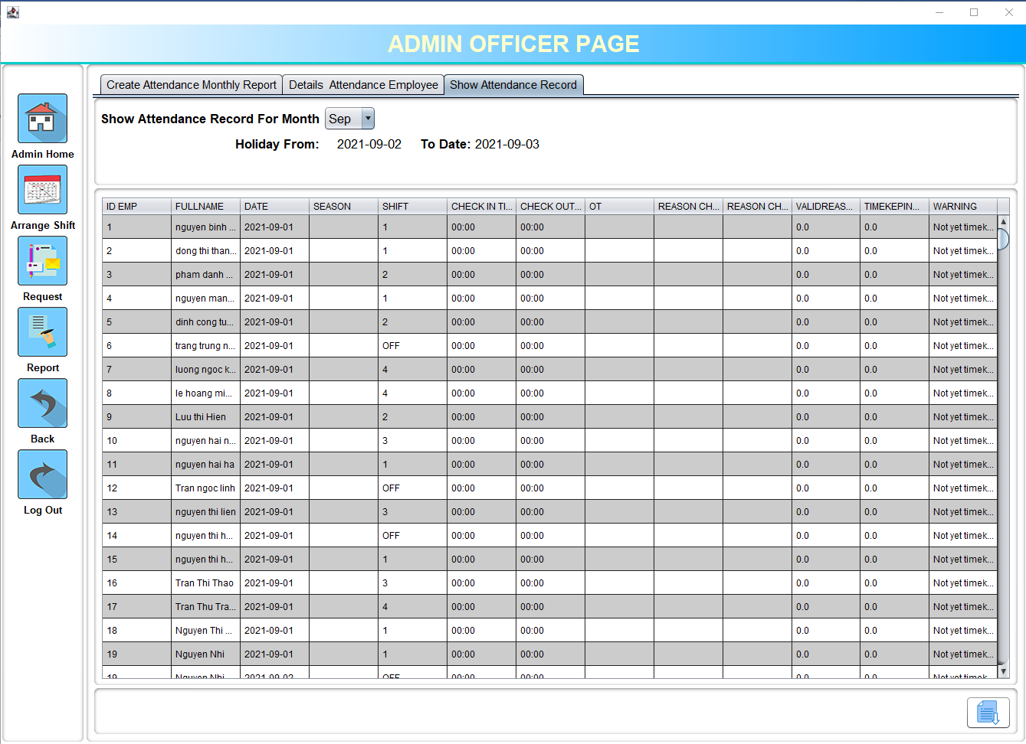

Click here

**2**

**1**

Figure 5.10. Attendance monthly detail report

|  |  |
| --- | --- |
| **Operation No.** | **Description** |
| 1 | Select month to show Attendance monthly detail report. |
| 2 | Export excel file of Attendance monthly detail report. |

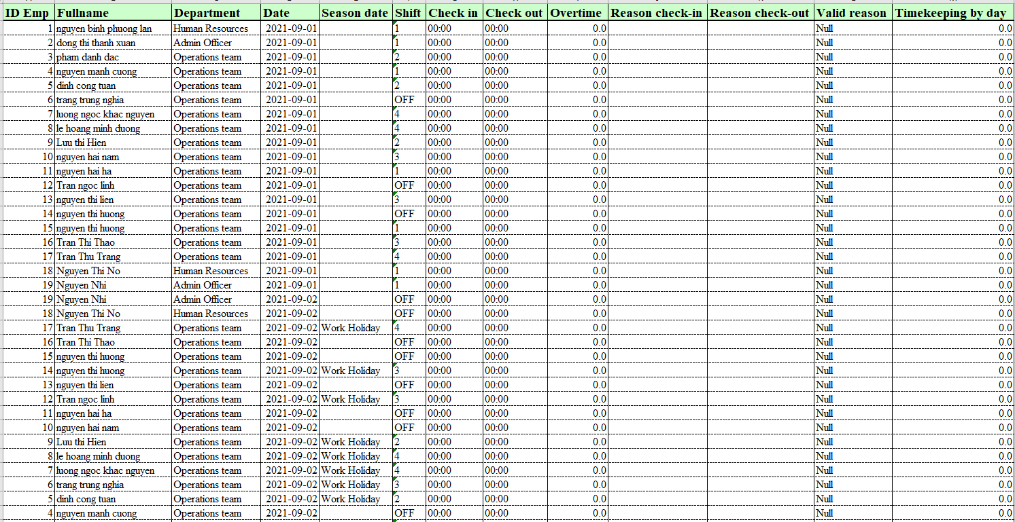

Figure 5.11. File excel of Attendance monthly detail report

## 8. LOG OUT AND BACK

### 8.1. Description

Admin can log out and back to the main page after using.

Admin also can back to choose user type page to go to a personal page.

### 8.2. Design and operation

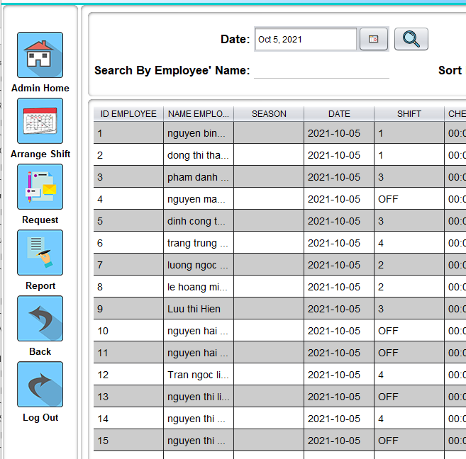

**2**

**1**

Figure 5.12. Button side



**3**

Figure 5.13. Select user type

|  |  |
| --- | --- |
| **Operation No.** | **Description** |
| 1 | Back to select user type page. |
| 2 | Logout back to the main page. |
| 3 | Go to personal page. |



## CHAPTER 6: HR GUIDE

## 1. MAIN

Same features as employee account - See instruction in section 1-Chapter 4: Employee guide

## 2. ATTENDANCE RECORD

Same features as employee account - See instruction in section 2-Chapter 4: Employee guide

## 3. LOGIN

Same features as employee account - See instruction in section 3-Chapter 4: Employee guide

## 4. EMPLOYEE

### 4.1. Description

This is the default page when accessing the HR management system. This page shows all employee's information, supports search engines and data filtering to make finding information easier.

### 4.2. Design and operation

After logging in, the user type selection page will display.

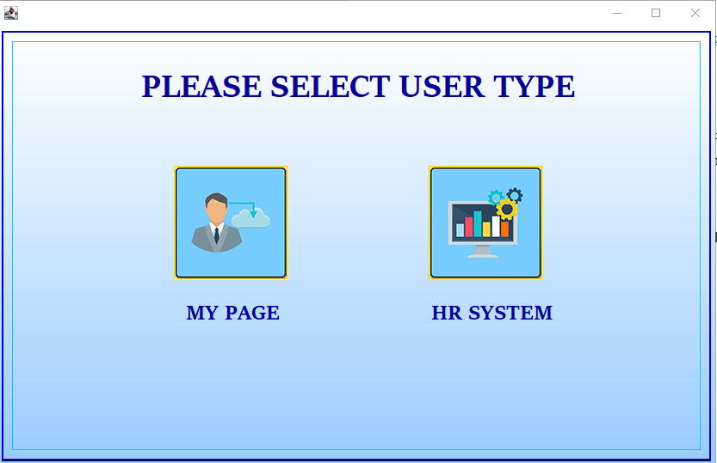

Click here

Figure 6.1. Select user type

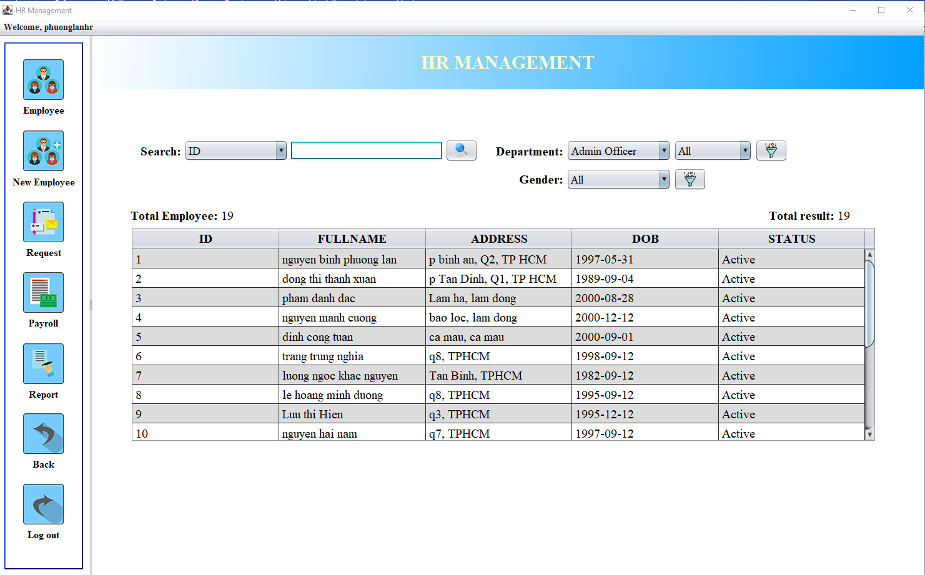

**3**

**2**

**1**

Figure 6.2. Employee

|  |  |
| --- | --- |
| **Operation No.** | **Description** |
| 1 | Search employee with field: id, fullname, username, date of birth (month & year), onboard (month & year), phone, address. |
| 2 | Sort by department and gender: (can sort in combination with search engine) |
| 3 | Sort by gender (can sort in combination with search engine) |

Right-click on selected employee to show more detail.

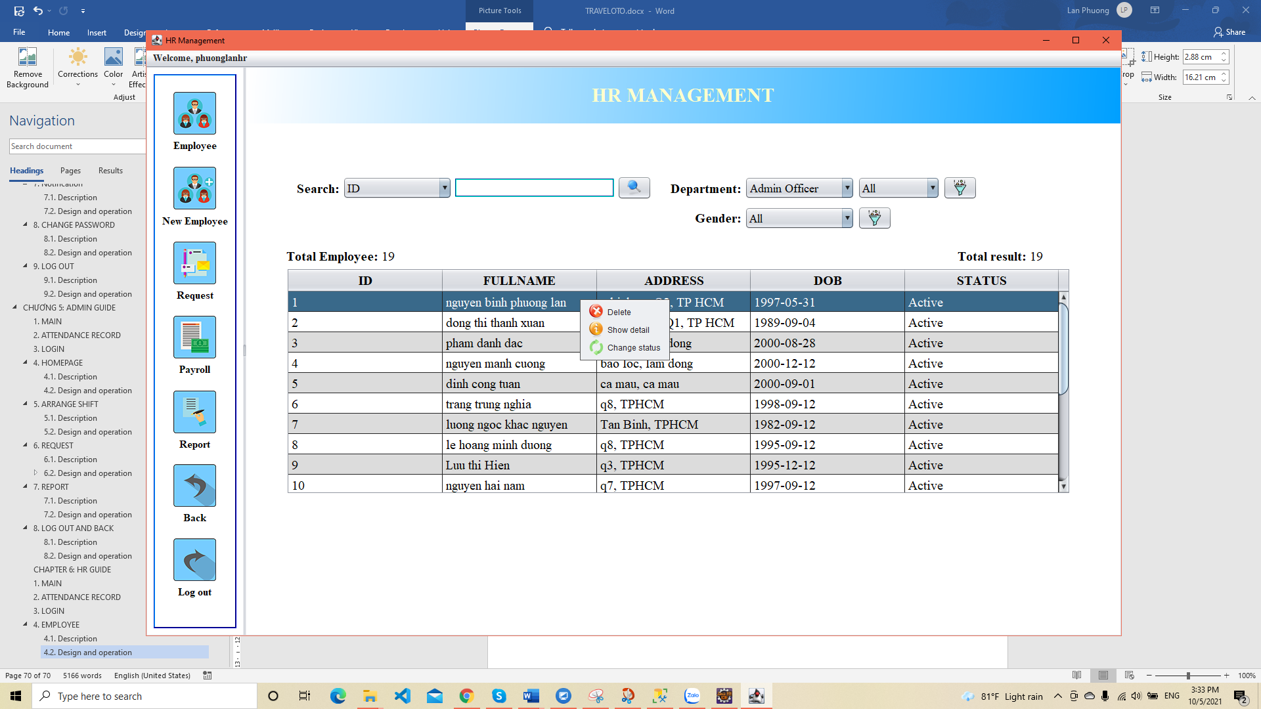

**3**

**2**

**1**

Figure 6.3. Right click on row

|  |  |
| --- | --- |
| **Operation No.** | **Description** |
| 1 | Delete: change employee status to “non-active” and delete login information (username and password). |
| 2 | Show employee’s information detail. |
| 3 | Change employee status (“active” or “non-active”) |

## 5. EMPLOYEE DETAIL INFORMATION

### 5.1. Description

This page will display details of employee information and allows to edit information except username and employee id.

### 5.2. Design and operation

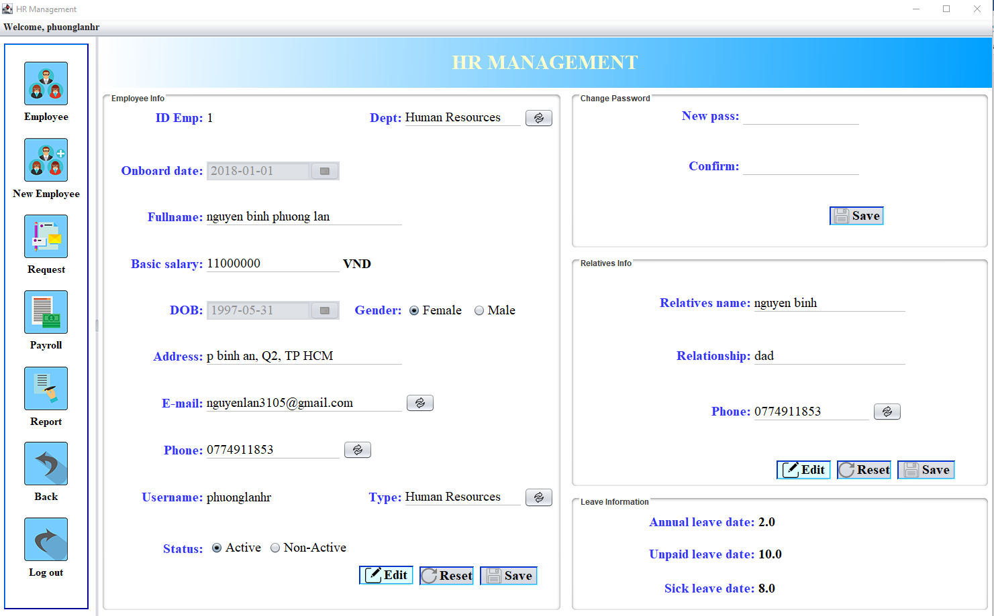

**4**

**3**

**2**

**1**

Figure 6.4. Employee detail info

|  |  |
| --- | --- |
| **Operation No.** | **Description** |
| 1 | Click on button No.1 to edit info.  After the click, “Reset” and “Save” button will enable. |
| 2 | Click on button No.2 to reset info. |
| 3 | Click on button No.3 to update info. |
| 3 | Click on button No.4 and the same button in other field to edit info. |

For changing password information, an email will automatically send a new password notification to employee e-mail.

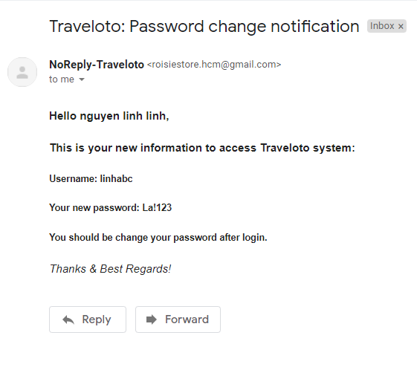

Figure 6.5. Email notify password change

## 6. ADD NEW EMPLOYEE

### 6.1. Description

This page allows to enter new employee's information into the system.

### 6.2. Design and operation

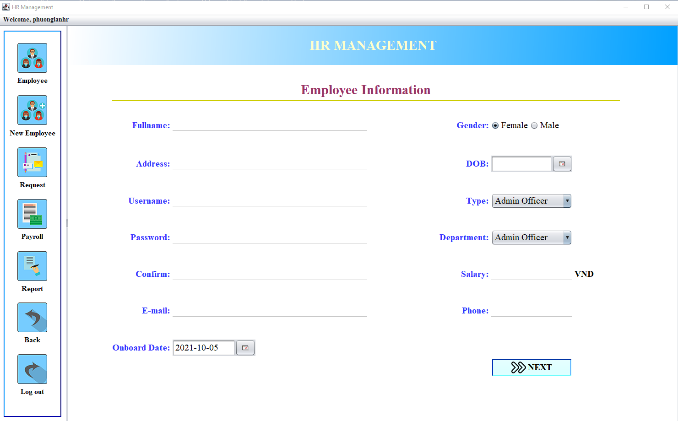

Click here for next step

Click here

Figure 6.6. Employee information

|  |  |
| --- | --- |
| **Field** | **Validation** |
| **Fullname** | * This field is mandatory. * Fullname must include: at least 5 chars - maximum 50 chars (only alphabet) |
| **Address** | * This field is mandatory. * Address must include: at least 5 chars - maximum 50 chars (not include special characters) |
| **Username** | * This field is mandatory. * Username must include: at least 3 chars - maximum 30 chars (not include special characters and space). * This field will be used as a login credential along with the password. * Username must be unique in the system. |
| **Password** | * This field is mandatory. * This field will be used as a login credential along with a username. * Password must include: at least 6 char, at least: one digit, one lower, one upper alpha char, one special char and does not contain space, tab. * Hashpass when insert in database. |
| **Confirm** | * This field is mandatory. * This field must be matched with the “Password” field. |
| **E-mail** | * This field is mandatory. * Must be an valid e-mail * E-mail must be unique in the system. |
| **Onboard day** | * This field is mandatory. |
| **Gender** | * This field is mandatory. |
| **Date of birth** | * This field is mandatory. * Minimum age is 18 years old. |
| **Type ID** | * This field is mandatory. * Set user type for employee * Three type of user:  1. Admin Officer 2. Employee 3. Human Resources |
| **Department** | * This field is mandatory. * Three department:  1. AO (Admin Officer) 2. HR (Human Resources) 3. OP (Operations team) |
| **Salary** | * This field is mandatory. * Only number and divisible by 100.000. |
| **Phone** | * This field is mandatory. * Vietnam phone number (10 number). * Phone must be unique in the system. |

After fill all employees’ information, click on next button to add relatives information.

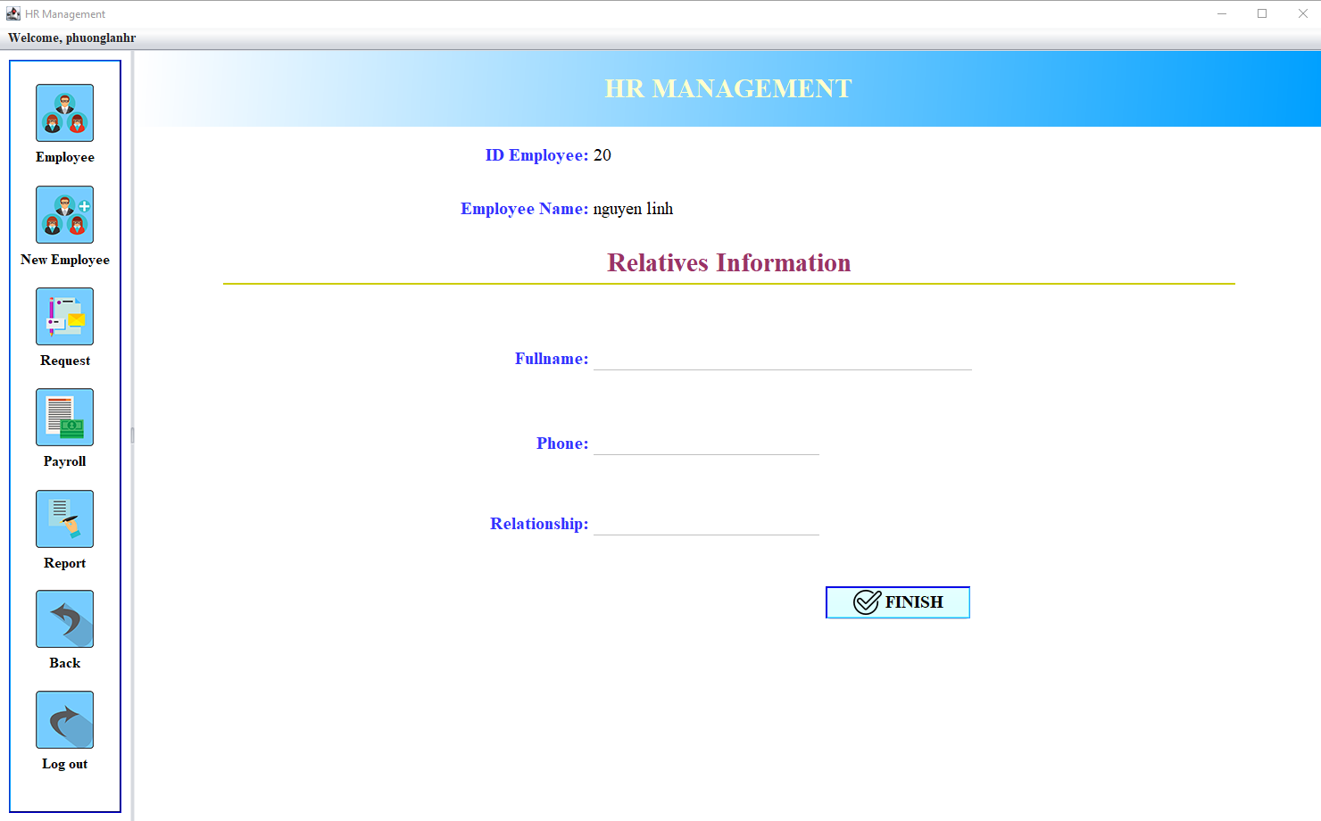

Figure 6.7. Relatives information

|  |  |
| --- | --- |
| **Field** | **Validation** |
| **Fullname** | * This field is mandatory. * Fullname must include: at least 5 chars - maximum 50 chars (only alphabet) |
| **Phone** | * This field is mandatory. * Vietnam phone number (10 number). * Phone must be unique in the system. |
| **Relationship** | * This field is mandatory. * Relationship must include: at least 3 chars - maximum 20 chars (only alphabet). |

Click on the “Finish” button to complete the process and send email notifications about login information for new employee.

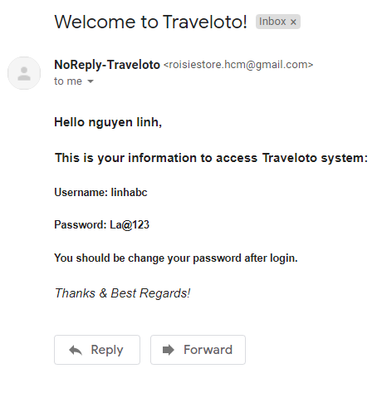

Figure 6.8. Email notify login information

**Default information for new employees:**

* Annual leave (12 days/year): when inserting the default annual leave date is 1 day, after each month (1st of the month) will automatically add 1 day for annual leave.
* Unpaid leave: the default unpaid leave is 15 days/year.
* Sick leave: the default sick leave day is 30 days/year.
* Status default is “Active”.

## 7. REQUEST

### 7.1. Description

This page will display information about leave requests from admin. HR will base on the information received to update the employee's leave and will send feedback back to the admin when complete update.

### 7.2. Design and operation

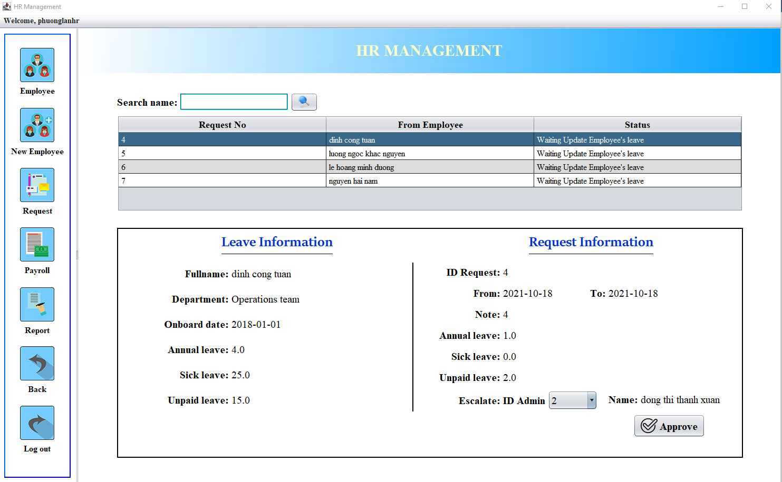

**2**

**4**

**3**

**1**

Click here

Figure 6.9. Show request

|  |  |
| --- | --- |
| **Operation No.** | **Description** |
| 1 | Search request by name. |
| 2 | Click on selected row to show detail request on form below. |
| 3 | Click on combo box No.3 to select Admin to send information when update complete. |
| 4 | Click on button No.4 to update employee’s leave and send information for selected admin. |

## 8. PAYROLL

### 8.1. Description

This is the salary calculation page for employees after the admin has generated the employee's monthly attendance report.

### 8.2. Design and operation

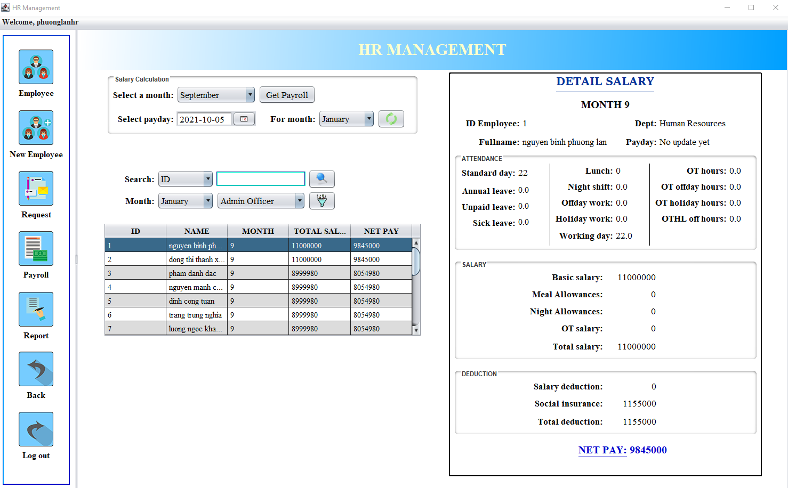

**1**

**6**

**5**

**4**

**3**

**2**

Click here

Figure 6.10. Payroll

|  |  |
| --- | --- |
| **Operation No.** | **Description** |
| 1 | Select a month and click on the “Get payroll” button to generate payroll. Only generate payroll for the month that has been generated attendance monthly report.  If there is any change in the monthly attendance monthly report, the payroll of that month can be updated (if the payroll of that month has been generated).  When generating the payroll, the system will also update the monthly leave (+1 for annual leave on the 1st of every month) and update the annual leave (update the leave on January 1st: annual leave: 1; unpaid leave: 15; sick leave: 30) for employees. |
| 2 | Select the pay date for the monthly salary period. |
| 3 | Select month for update pay date. |
| 4 | Search payroll of employees by fields: id, fullname and month. |
| 5 | Sort payroll by month and department. |
| 6 | Click on the row to view the detailed salary of employees on the detailed salary form. |

**Salary regulations:**

* Working time:
* Shift 1: 8:00 am – 5:00 pm
* Shift 2: 6:00 am – 3:00 pm
* Shift 3: 11:00 am – 8:00 pm
* Shift 4: 2:00 pm – 11:00 pm
* Administrative and HR department, working in administrative shifts (shift 1)
* Operation department: Employees are divided into groups, working in divided shifts.
* Standard working day of 1 month: 22 days.
* Basic salary according to the agreement between the company and the employee.
* 1 day salary = basic salary / 22 days.

|  |  |
| --- | --- |
| **Number AL** | Annual leave in month |
| **Number UL** | Unpaid leave in month |
| **Number SL** | Sick leave in month (Unpaid salary, only social insurance benefits) |
| **Total fullday** | Total working day with meal allowance. |
| **Working offday** | Total working on off day (1 off day = 1 day salary * 2 ) |
| **Working holiday** | Total working on holiday day (1 holiday day = 1 day salary * 3) |
| **Working day** | Total normal working day (excluding holiday and off day) =  22 – AL – UL – SL – holiday – offday |
| **Total shift 3** | Total number of days working shift 3. |
| **Total shift 4** | Total number of days working shift 4. |
| **totalOTonday** | Total overtime hours in normal working day. |
| **totalOToffday** | Total overtime hours in off day. |
| **totalOTHL** | Total overtime hours in holiday. |
| **totaloffOTHL** | Total overtime hours in compensatory leave for holiday. |
| **basicsalary** | Basic salary |
| **Deduction** | Salary deduction due to not coming to work on time. |
| **Insurance** | Insurance deduction = basicsalary * 10.5% |
| **Meal allowances** | 50.000 * Total fullday |
| **Night allowances** | 100.000 * (Total shift 3 + Total shift 4) |
| **OT onday salary** | (1 day salary/ 8h * 1,5) * totalOTonday |
| **OT offday salary** | (1 day salary / 8h * 2) * totalOToffday |
| **OT holiday salary** | (1 day salary / 8h * 4) * totalOTHL |
| **OT off holiday salary** | (1 day salary / 8h * 3) * totaloffOTHL |
| **Total OT salary** | OT onday salary + OT offday salary + OT holiday salary + OT off holiday salary |
| **Total salary** | 1 day salary * ((22 - numberUL - numberSL) + workingHL * 3 + workingoffday * 2) + Night allowances + Meal allowances + totalOTSal) |
| **Incom (net pay)** | Total salary - deduction - insurance |

## 9. REPORT

### 9.1. Description

The report will summarize the monthly salary that the company pays to employees. The monthly salary report will statistics total salary in a month, total allowances, total deduction, the average salary paid for one employee, the highest salary, the lowest salary. This makes performance appraisals more effective.

### 9.2. Design and operation

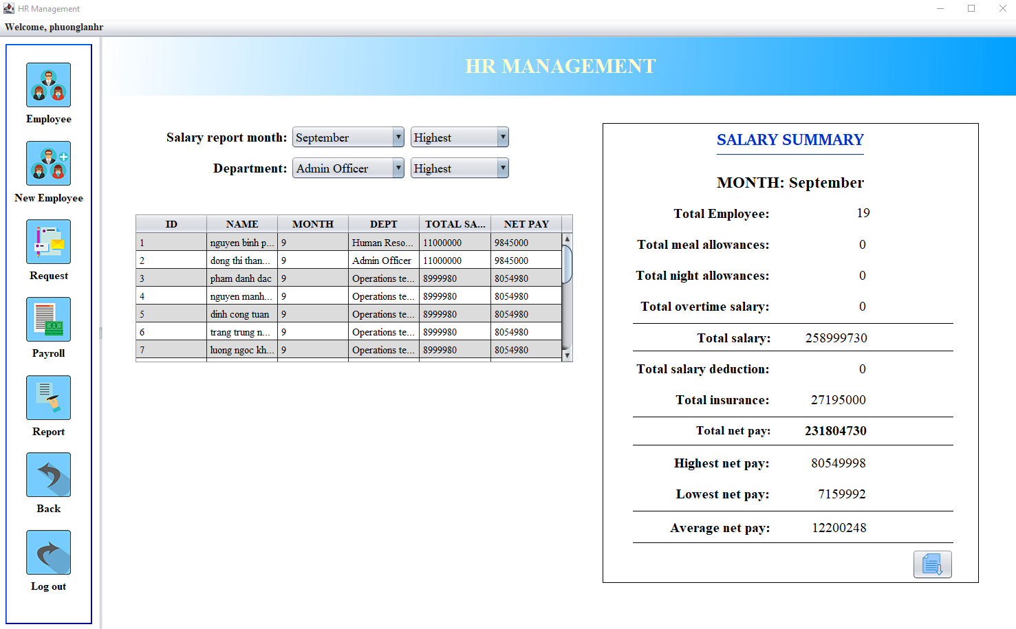

**5**

**4**

**3**

**2**

**1**

Click here

Figure 6.11. Salary monthly report

|  |  |
| --- | --- |
| **Operation No.** | **Description** |
| 1 | Select month to show salary summary. (Only show salary summary of the month that generate payroll already). |
| 2 | Sort list salary by highest salary or lowest salary of the month |
| 3 | Filter list salary by department. |
| 4 | Sort list salary by highest salary or lowest salary of the department. |
| 5 | Export file excel of salary monthly report. |

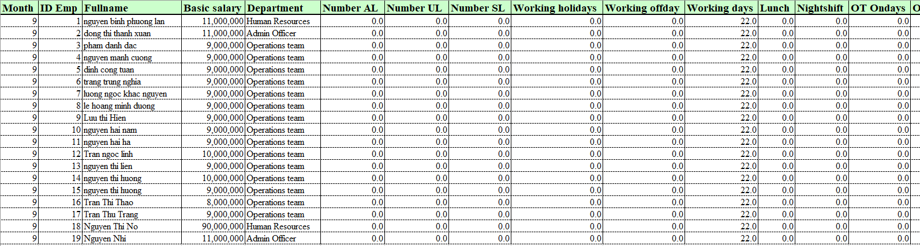

Figure 6.12.File excel of salary monthly report

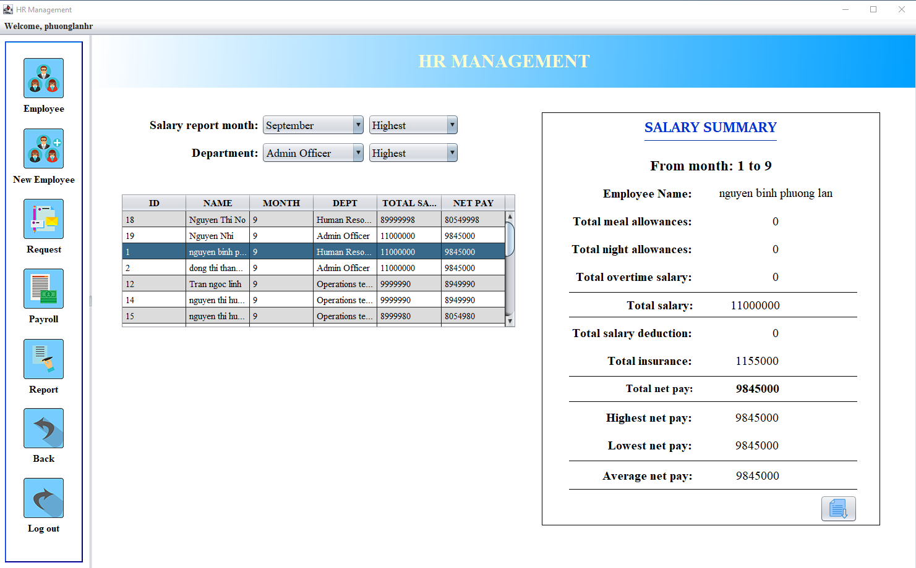

**2**

**1**

Figure 6.13. Employee salary summary report

|  |  |
| --- | --- |
| **Operation No.** | **Description** |
| 1 | Click on row to show selected employee salary summary report from January to the current month. |
| 2 | Export file excel of employee salary report from January to the current month. |

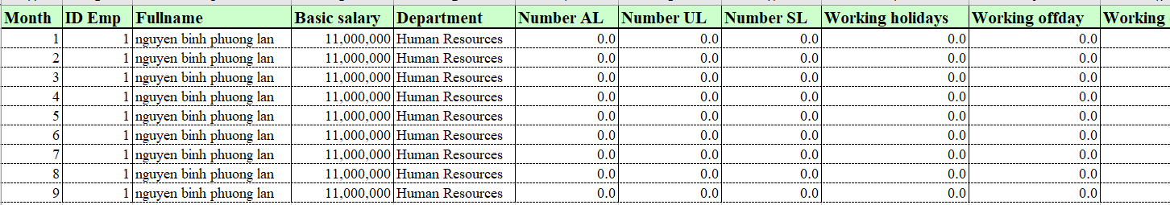

Figure 6.14. File excel of employee salary report

## 10. LOG OUT AND BACK

### 10.1. Description

HR can log out and back to the main page after using.

HR also can back to choose user type page to go to a personal page.

### 10.2. Design and operation

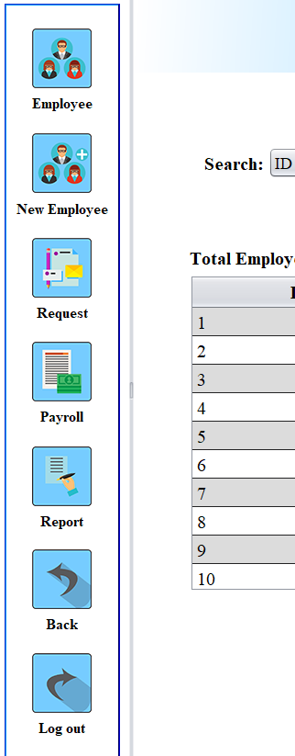

**2**

**1**

Figure 6.15. Button side

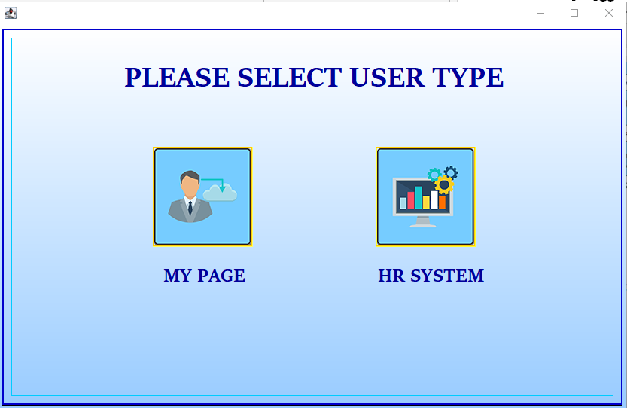

**3**

Figure 6.16. Select user type

|  |  |
| --- | --- |
| **Operation No.** | **Description** |
| 1 | Back to select user type page. |
| 2 | Logout back to the main page. |
| 3 | Go to personal page. |



# CHAPTER 7: DEVELOPER GUIDE

## 1. INSTALL SQL SERVER

* Open and connect to SQL Server.

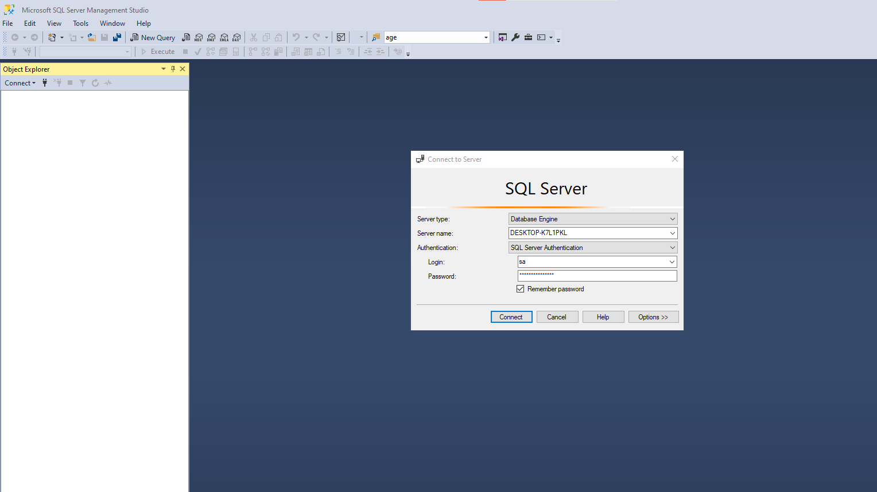

* Select Labour.sql in folder “labour”

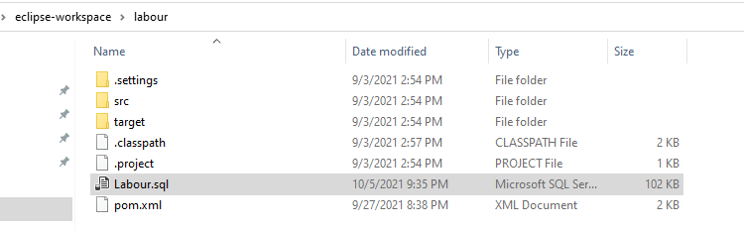

Select this

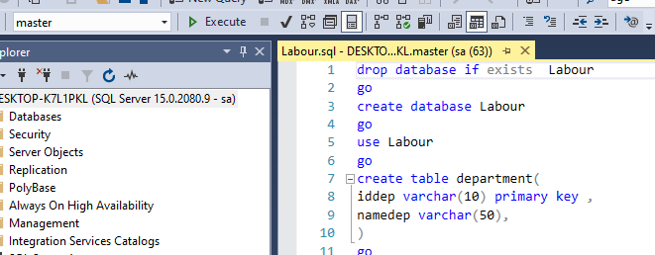

Pointer

Click here

* Put the mouse pointer at “drop database…” and click on “Exceute” to create database.

## 2. INSTALL JOB IN SQL SERVER.

* Search “services.msc”

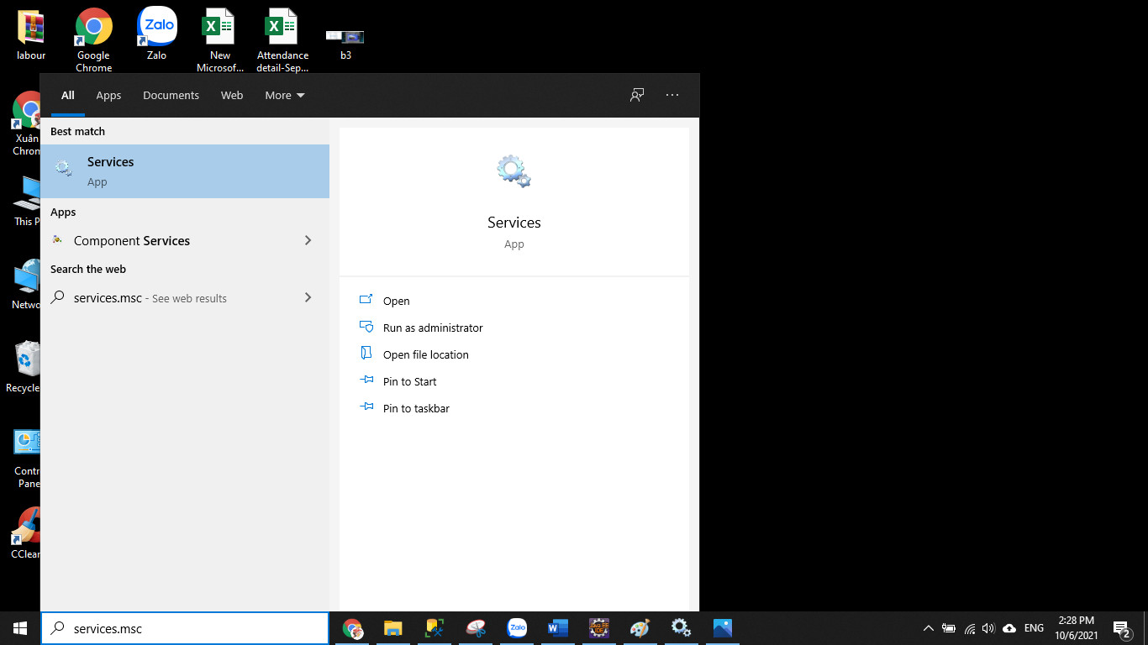

* Select “SQL Server Agent (MSSQL SERVER) >> Right click >> Start

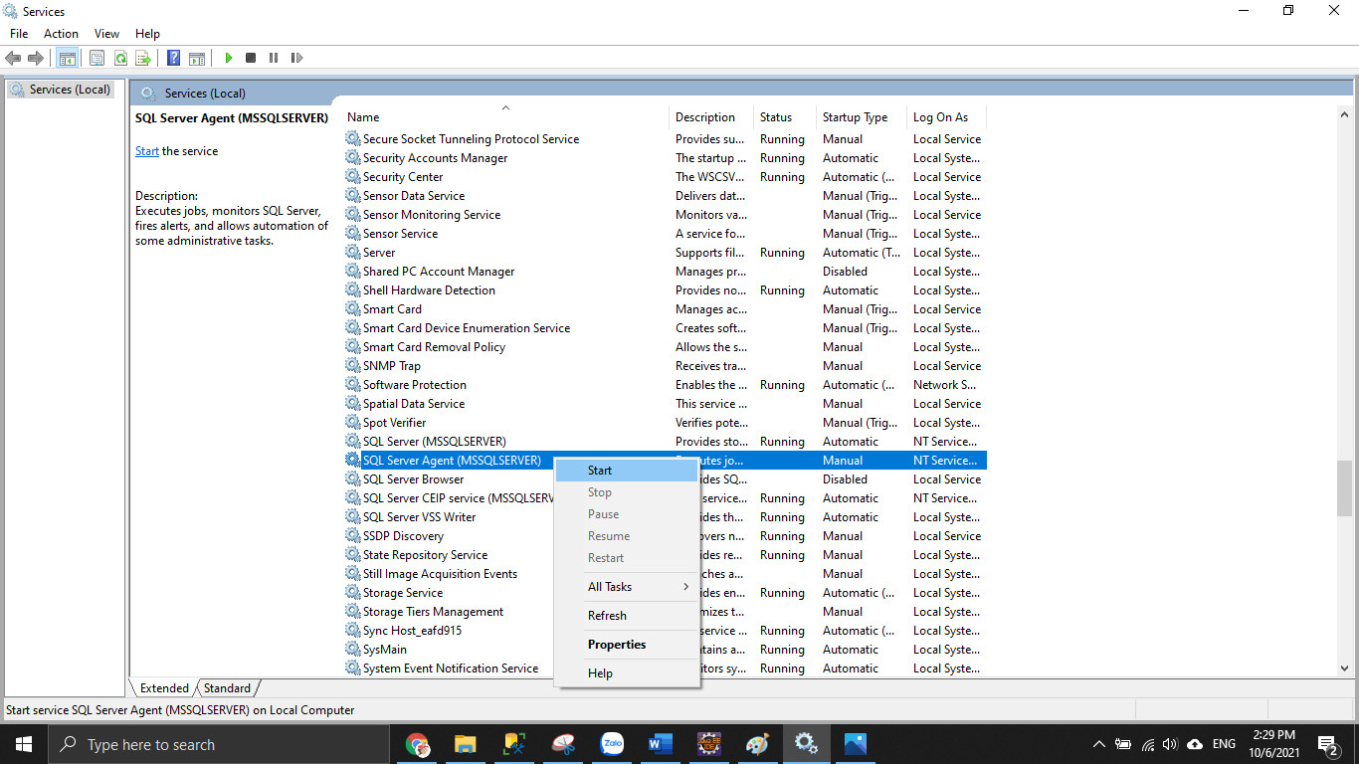

=> Status: running

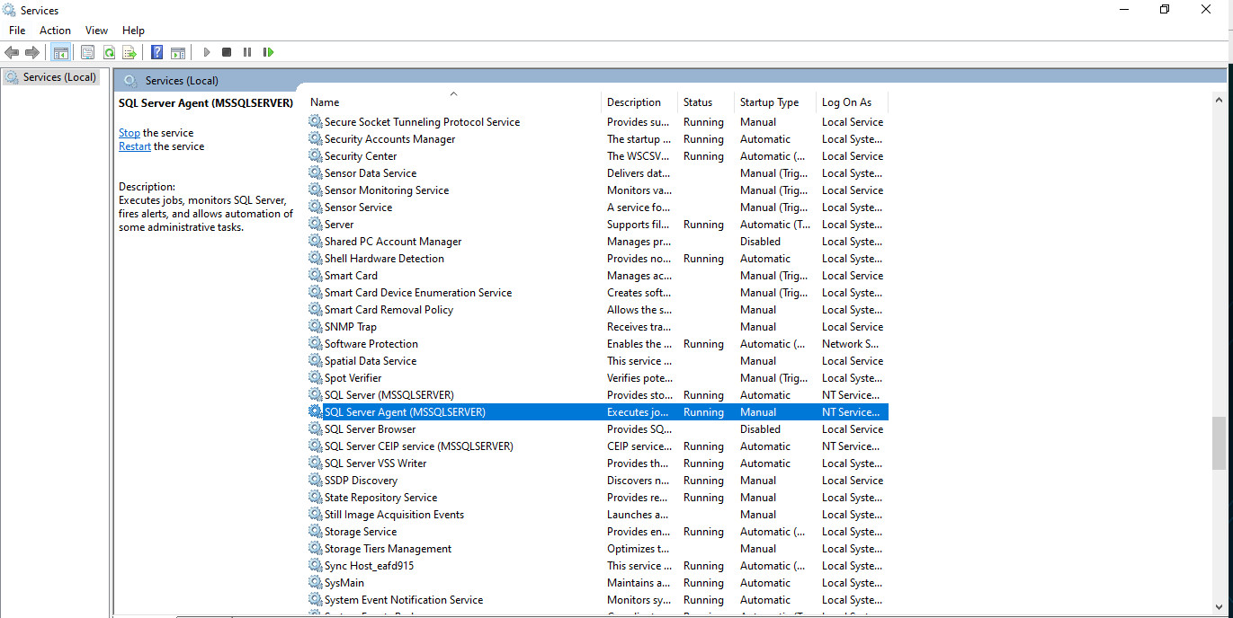

* Select “SQL Server Agent (MSSQL SERVER) >> Right click >> Properties

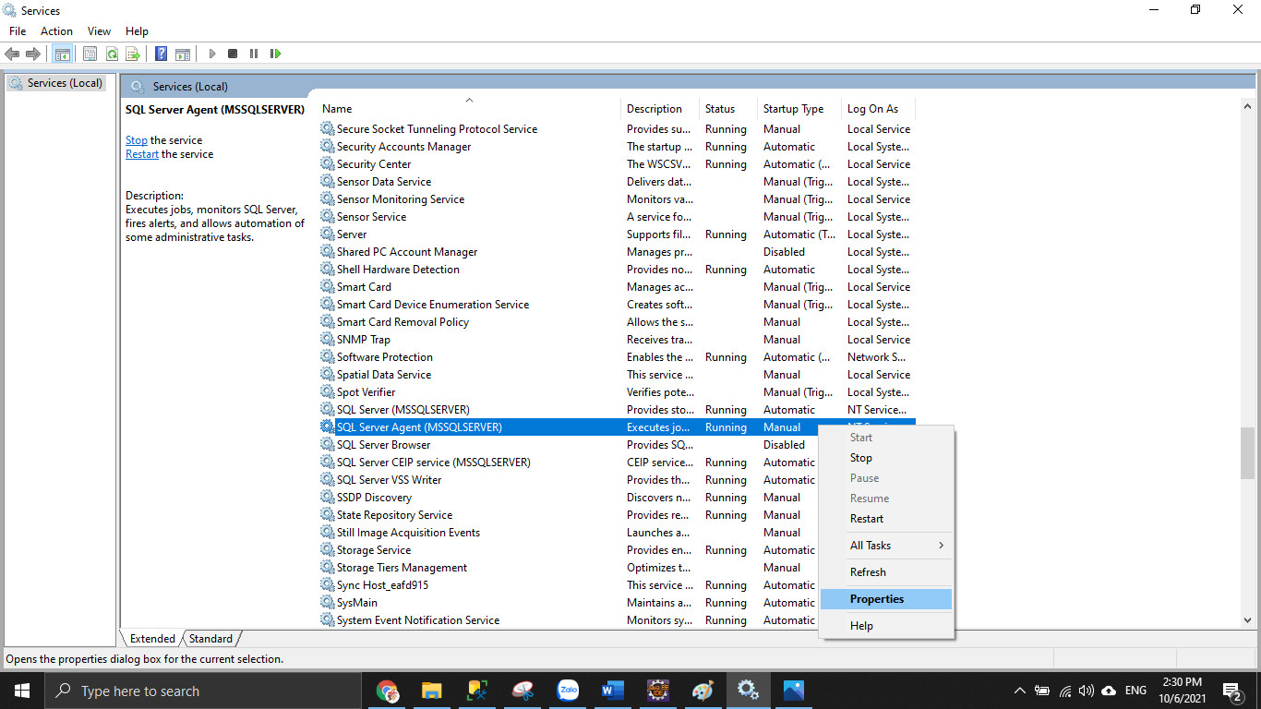

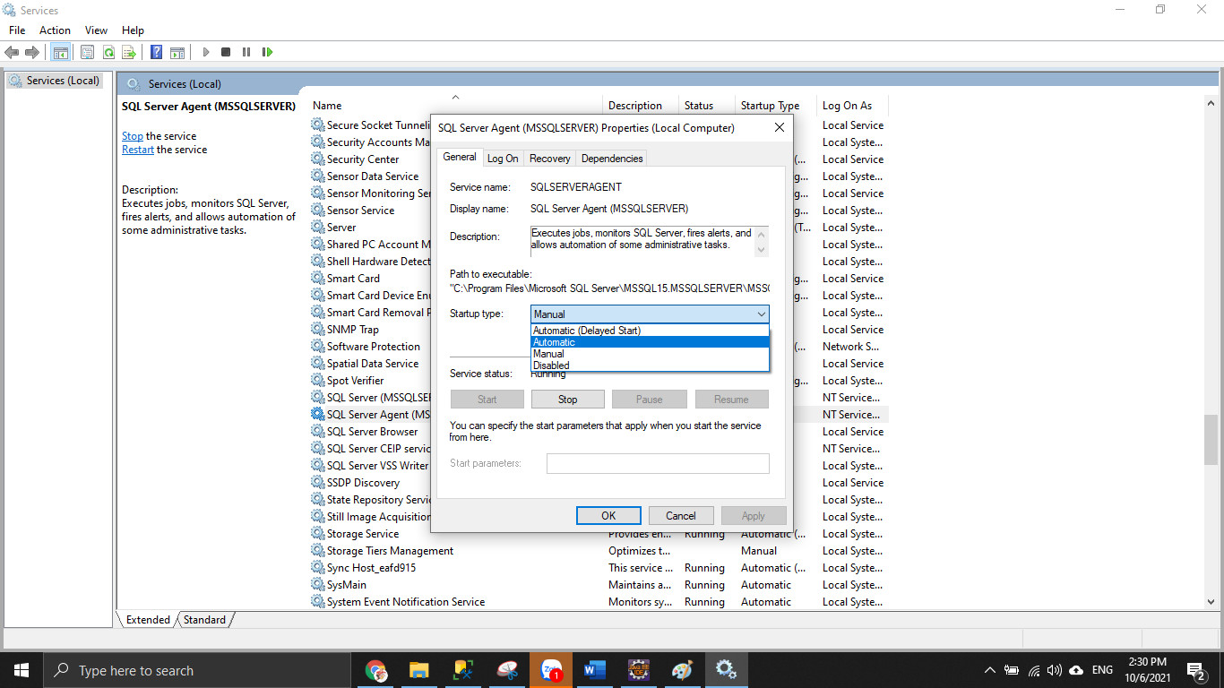

* On startup type >> select “Automatic”

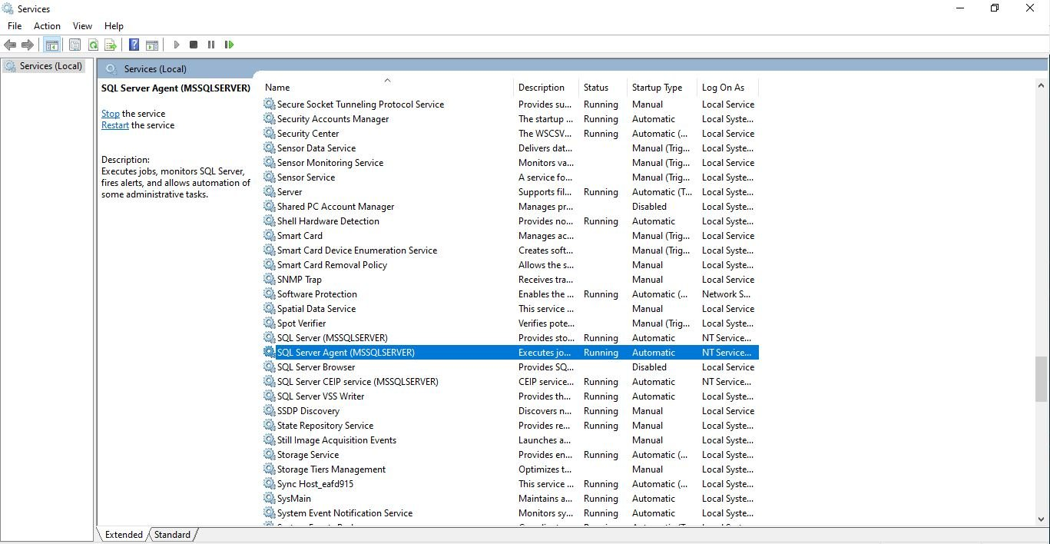

=> Status: running and Startup type: Automatic >> Set up successful

* Open SQL Server >> click on “SQL Sever Agent” >> right clicl on”Jobs” >> select “New job”

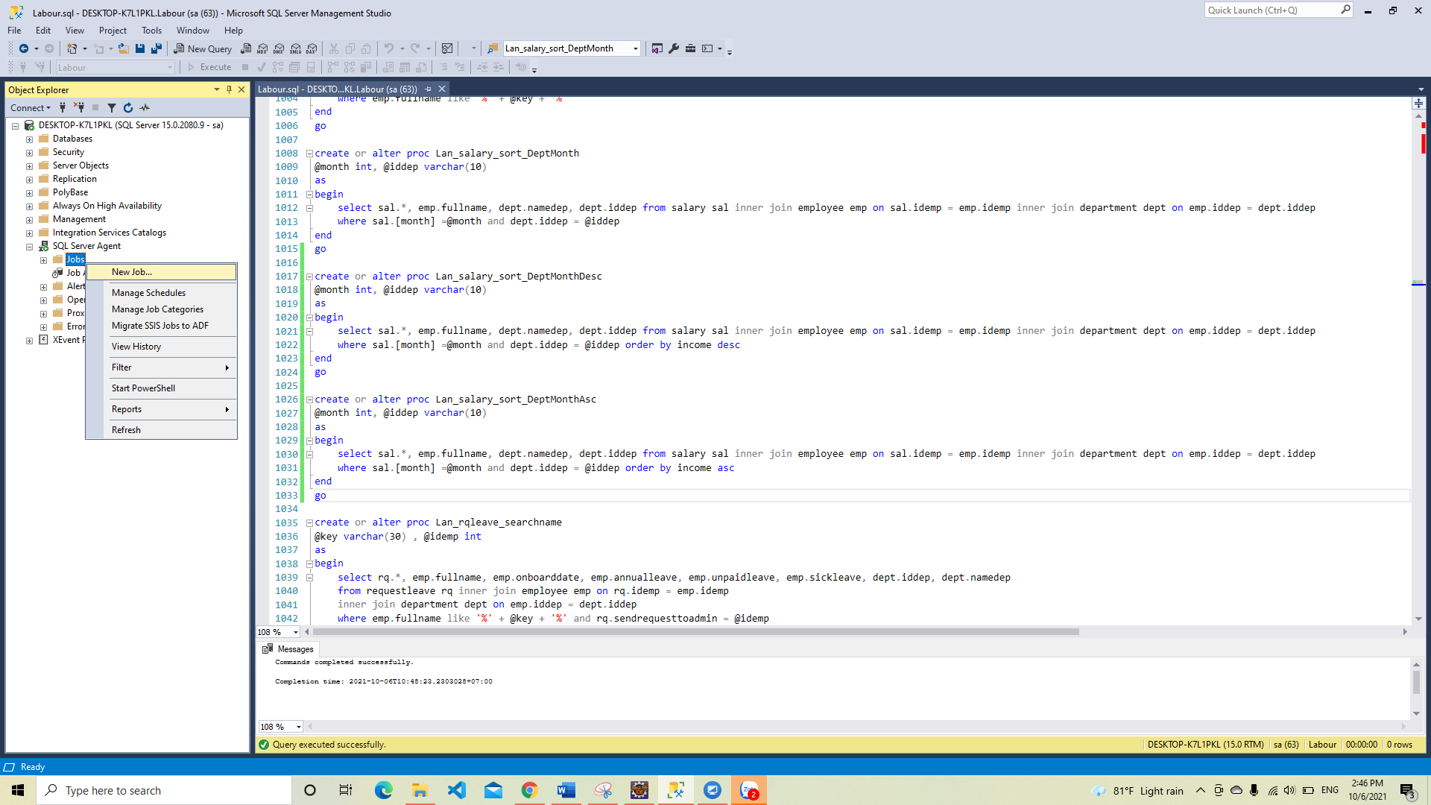

* Select General tab >> on Name type: “deleterequestleave” (or any name).

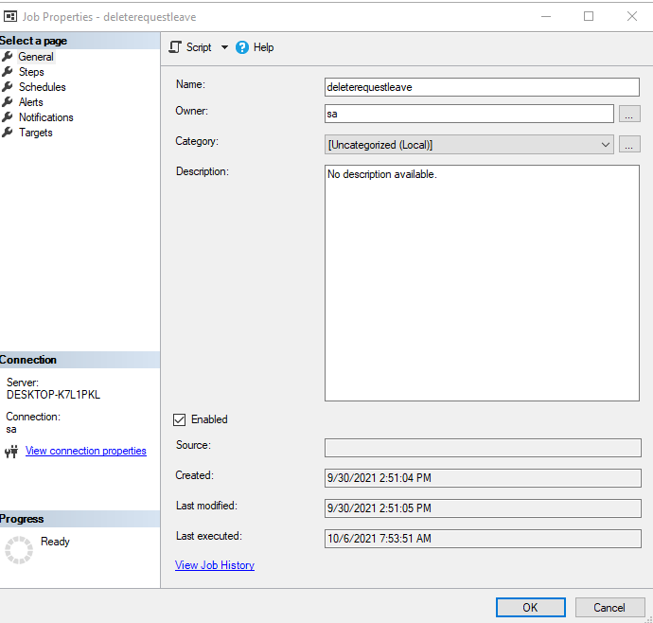

* Select Steps tab >> click on New

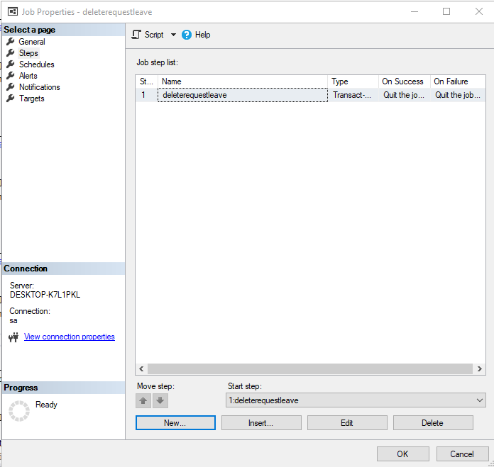

**Setting Job for store procedure: deleterequestleave**

* Select General >> on step name type: “deleterequestleave”
* On command >> type: “exec deleterequestleave” (store procedue name)>> click Parse

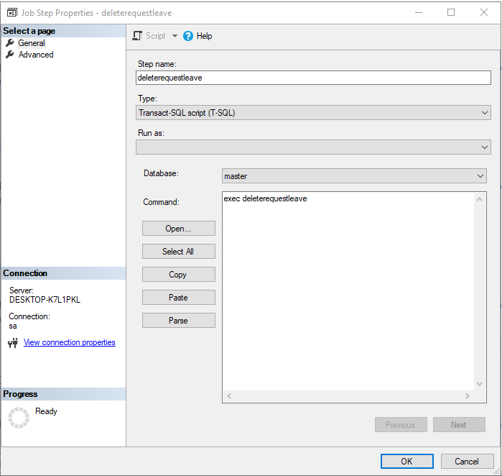

* Select Advance >> On success action >> select “Go to next step” >> OK

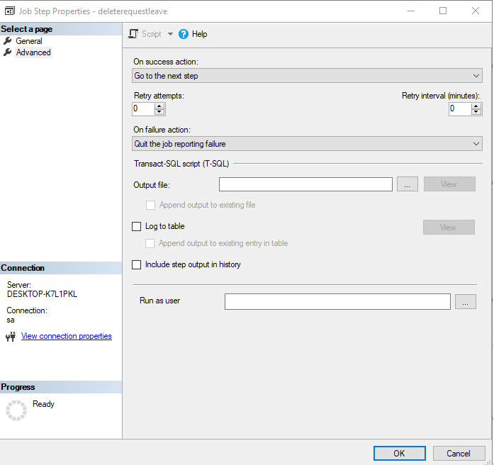

* Select Schedule >> click on New

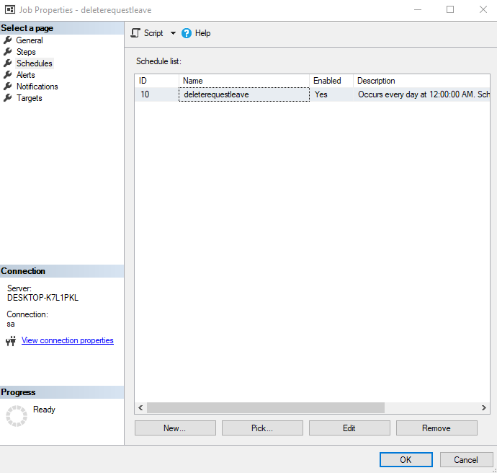

* Set information like image below >> OK

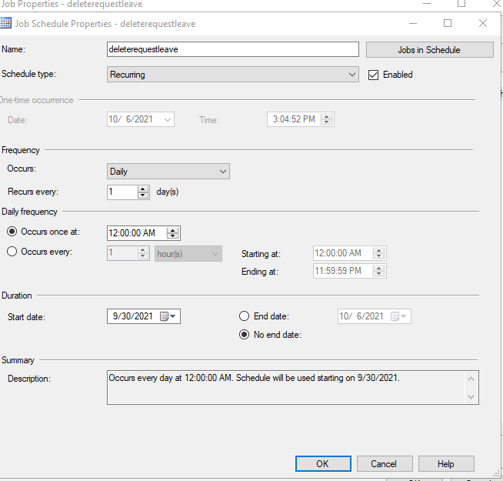

* Setting Job successful.

**Setting Job for store procedure: deleterequestChangeshift**

Follow the same steps for store “deleterequestleave”, change store name to “deleterequestChangeshift”.

## 3. INSTALL IN ECLIPSE-WORKSPACE.

* Select scr/main/java/common/ConnectDB.java

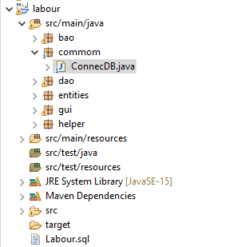 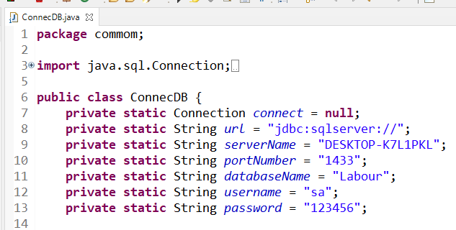

* Change “serverName” to the correct “serverName” on your computer.
* Change the “username” and “password” with the correct connection information to the sql server on your computer.

## 4. RUN APPLICATION

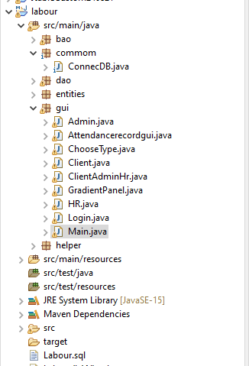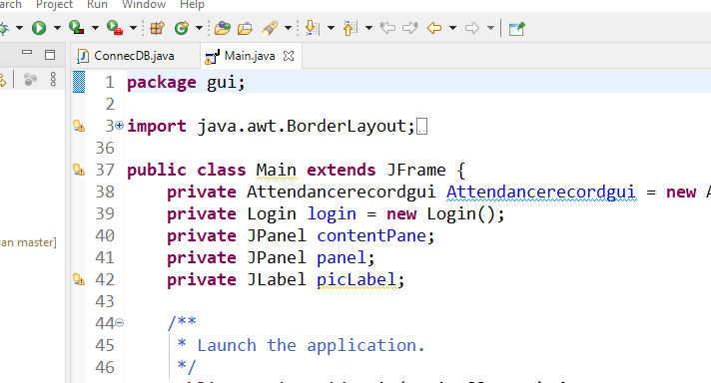

* Select scr/main/java/gui/Main.java >> Run

This main page will display to access the system.

